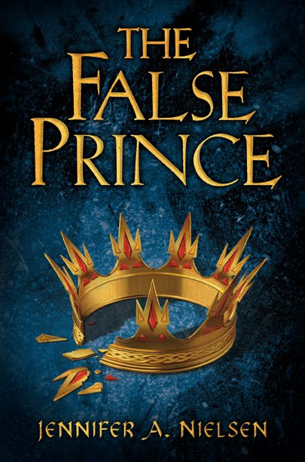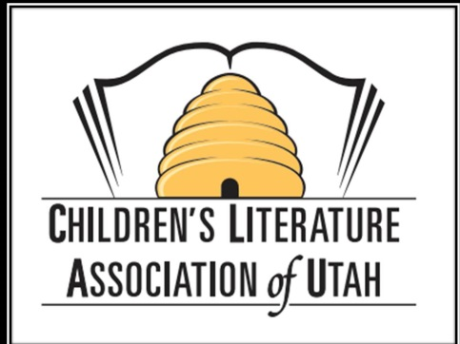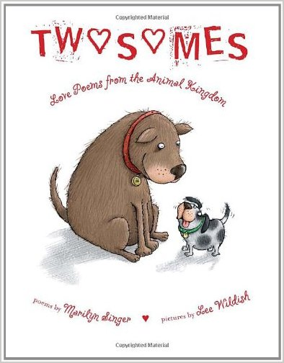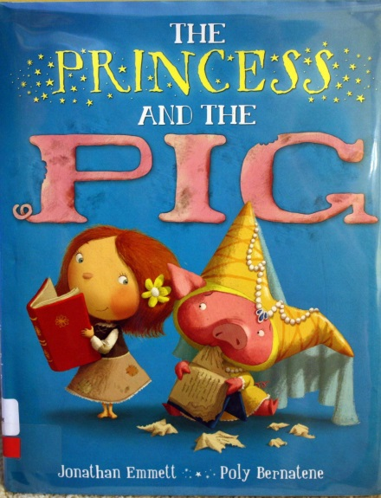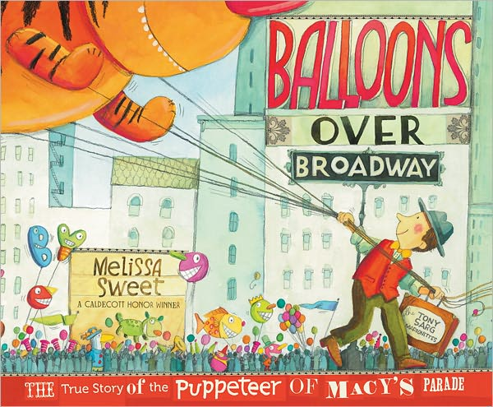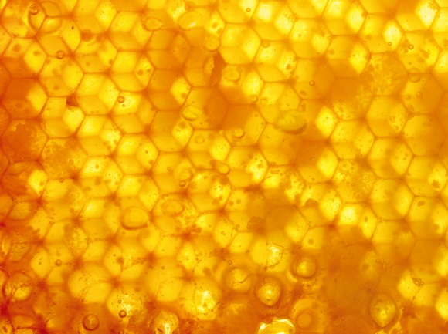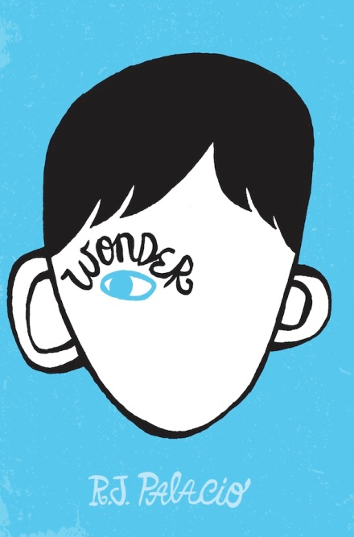

**Beehive Book**

**Awards**

**2014**

**Poetry Book Winner**

***Twosomes***

by Marilyn Singer,

illustrated by Lee Wildish

**Young Adult Book Winner**

***The False Prince***

by Jennifer A. Nielsen

**Picture Book Winner**

***The Princess and the Pig***

by Jonathan Emmett,

illustrated by Poly Bernatenene

**Informational Book Winner**

***Balloons Over Broadway: The True Story of the Puppeteer of the Macy’s Parade***

by Melissa Sweet

**Children’s Book Winner**

***Wonder***

by R. J. Palacio