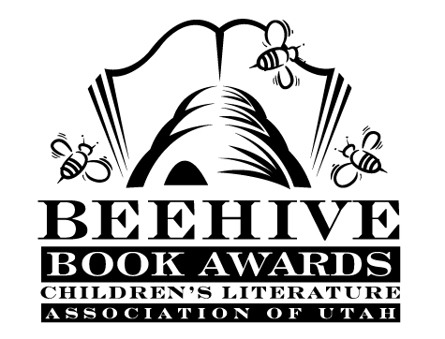

Children’s Fiction Books—Beehive Nominees 2015

- Breathing Room by Marsha Hayles
- Duke by Kirby Larson
- Escape from Mr. Lemoncello's Library by Chris Grabenstein
- I Survived Hurricane Katrina, 2005 (I Survived) by Lauren Tarshis, illustrated by Scott Dawson
- Of Giants and Ice (The Ever Afters #1) by Shelby Bach, illustrated by Cory Loftis
- One Dead Spy: Nathan Hale’s Hazardous Tales by Nathan Hale
- Paperboy by Vince Vawter *
- Rump: The True Story of Rumpelstiltskin by Liesl Shurtliff
- Sky Jumpers (Sky Jumpers #1) by Peggy Eddleman
- Wild Born (Spirit Animals #1) by Brandon Mull

Picture Books—Beehive Nominees 2015

- Andrew Drew and Drew by Barney Saltzberg
- Count the Monkeys by Mac Barnett, illustrated by Kevin Cornell
- The Day the Crayons Quit by Drew Daywalt, illustrated by Oliver Jeffers
- Journey by Aaron Becker
- I Hate Picture Books! by Timothy Young
- I Need My Own Country! by Rick Walton, illustrated by Wes Hargis
- Mustache Baby by Bridget Heos, illustrated by Joy Ang
- Penguin and Pinecone by Salina Yoon
- Ribbit! by Rodrigo Folgueira, illustrated by Poly Bernatene
- Sophie's Squash by Pat Zietlow Miller, illustrated by Anne Wilsdorf
- That Is Not a Good Idea! by Mo Willems
- Xander's Panda Party by Linda Sue Park illustrated by Matt Phelan

Informational Books—Beehive Nominees 2015

- Barbed Wire Baseball by Marissa Moss, illustrated by Yuko Shimizu
- Becoming Babe Ruth by Matt Tavares
- The Beetle Book by Steve Jenkins
- The Boy on the Wooden Box: How the Impossible Became Possible on Schindler's List by Leon
Leyson with Marilyn J Harran and Elisabeth B. Leyson
- The Camping Trip That Changed America: Theodore Roosevelt, John Muir, and our National Parks
by Barb Rosenstock, illustrated by Mordicai Gerstein
- Island: A Story of the Galapagos by Jason Chin
- Lincoln's Grave Robbers by Steve Sheinkin
- Nelson Mandela by Kadir Nelson
- Timeless Thomas: How Thomas Edison Changed Our Lives by Gene Barretta
- Who Says Women Can't Be Doctors: The Story of Elizabeth Blackwell by Tanya Lee Stone,
illustrated by Marjorie Priceman

Poetry Books—Beehive Nominees 2015

- Cat Talk by Patricia MacLachlan and Emily MacLachlan Charest, illustrated by Barry Moser
- Digger, Dozer, Dumper by Hope Vestergaard, illustrated by David Slonim
- Gone Fishing: A Novel In Verse by Tamera Will Wissinger, illustrated by Matthew Cordell
- Grumbles from the Forest: Fairy-tale Voices with a Twist by Jane Yolen and Rebecca Kai Dotlich,
illustrated by Matt Mahurin
- National Geographic Book of Animal Poetry: 200 Poems with Photographs that Squeak, Soar, and
Roar! edited by J. Patrick Lewis
- Poems to Learn by Heart selected by Caroline Kennedy, paintings by Jon J. Muth
- Sisters of Glass by Stephanie Hemphill
- When Mermaids Sleep by Ann Bonwill, illustrated by Steve Johnson & Lou Fancher

Young Adult Fiction Books—Beehive Nominees 2015

- Born of Illusion (Born of Illusion #1) by Teri Brown
- The Caged Graves by Dianne K. Salerni
- Cardboard by Doug TenNapel
- Guitar Notes by Mary Amato
- Insomnia (The Night Walkers #1) by J.R. Johansson
- My Family for the War by Anne C. Voorhoeve
- The Name of the Star (Shades of London #1) by Maureen Johnson
- Ship Out of Luck (Antsy Bonano #3) by Neal Shusterman
- Skinny by Donna Cooner
- Slated (Slated #1) by Teri Terry
- The Statistical Probability of Love at First Sight by Jennifer E. Smith *
- The Testing (The Testing #1) by Joelle Charbonneau *

