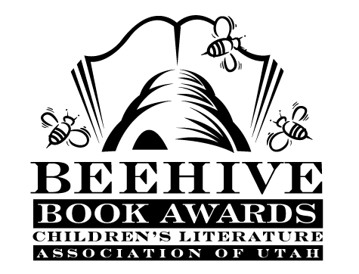

Children’s Fiction Books—Beehive Nominees 2014

- Brixen Witch by Stacy DeKeyser
- Close to Famous by Joan Bauer
- The Humming Room by Ellen Potter
- Icefall by Matthew Kirby
- Inside Out & Back Again by Thanhha Lai
- Malcolm at Midnight by W. H. Beck
- Three Times Lucky by Sheila Turnage
- Tuesdays at the Castle by Jessica Day George
- Wonder by R. J. Palacio
- Zita the Spacegirl, Book 1, Far From Home by Ben Hatke

Picture Books—Beehive Nominees 2014

- Bink & Gollie: Two For One by Kate DiCamillo and Alison McGhee, illustrated by Tony Fucile
- Boy + Bot by Ame Dyckman, illustrated by Dan Yaccarino
- Goldilocks and the Three Dinosaurs by Mo Willems
- How to Babysit a Grandpa by Jean Reagan, illustrated by Lee Wildish
- It’s a Tiger by David LaRochelle, illustrated by Jeremy Tankard
- Mitchell’s License by Hallie Durand, illustrated by Tony Fucile
- My Garden by Kevin Henkes
- Pete the Cat and His Four Groovy Buttons by Eric Litwin, illustrated by James Dean
- Plant a Kiss by Amy Krouse Rosenthal, illustrated by Peter H. Reynolds
- The Princess and the Pig by Jonathan Emmett and Poly Bernatene
- Stars by Mary Lyn Ray, illustrated by Marla Frazee
- Z is for Moose by Paul O. Zelinsky

Informational Books—Beehive Nominees 2014

- America is Under Attack: September 11, 2001: The Day the Towers Fell by Don Brown
- Balloons Over Broadway: The True Story of the Puppeteer of the Macy’s Parade by Melissa Sweet
- Barnum’s Bones: How Barnum Brown Discovered the Most Famous Dinosaur in the World by Tracy Fern
- Billy the Boy Wonder: The Secret Co-Creator of Batman by Marc Tyler Nobleman
- Bomb: The Race to Build—and Steal—The World’s Most Dangerous Weapon by Steve Sheinkin
- Harry Houdini: The Legend of the World’s Greatest Escape Artist by Janice Weaver
- Invincible Microbe: Tuberculosis and the Never-Ending Search for a Cure by Jim Murphy and Alison Blank
- It’s a Dog’s Life: How Man’s Best Friend Sees, Hears and Smells the World by Susan E. Goodman
- Just a Second by Steve Jenkins
- North: The Amazing Story of Arctic Migration by Nick Dowson

Poetry Books—Beehive Nominees 2014

- BookSpeak! Poems About Books by Laura Purdie Salas
- Last Laughs: Animal Epitaphs by J. Patrick Lewis and Jane Yolen
- Out of This World by Amy Sklansky
- Poems I Wrote When No One Was Looking by Alan Katz
- The President’s Stuck in the Bathtub by Susan Katz
- Shiver Me Timbers by Douglas Florian
- Swirl by Swirl: Spirals in Nature by Joyce Sidman
- Twosomes by Marilyn Singer

Young Adult Fiction Books—Beehive Nominees 2014

- Cinder by Marissa Meyer
- Code Name Verity by Elizabeth Wein*
- The False Prince by Jennifer A. Nielsen
- The Fault in Our Stars by John Green*
- Legend by Marie Lu
- Lions of Little Rock by Kristin Levine
- Rot and Ruin by Jonathan Maberry
- The Scorpio Races by Maggie Stiefvater*
- Shadow and Bone by Leigh Bardugo*
- Ungifted by Gordon Korman
- Welcome Caller, This is Chloe by Shelley Coriell
- Wrapped by Jennifer Bradbury

