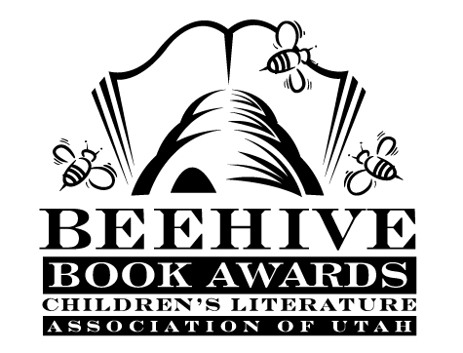
Children’s Fiction Books—Beehive Nominees 2013

- A Dog’s Way Home by Bobbie Pyron
- Edgar Allan’s Official Crime Investigation Notebook by Mary Amato
- The Emerald Atlas by John Stephens
- The Familiars by Adam Jay Epstein and Andrew Jacobson
- Heart of a Samurai by Margi Preus
- Lulu and the Brontosaurus by Judith Viorst; illustrated by Lane Smiths
- True (. . . Sort Of) by Katherine Hannigan
- Turtle in Paradise by Jennifer L. Holm
- The Unwanteds by Lisa McMann
- With a Name Like Love by Tess Hilmo

Picture Books—Beehive Nominees 2013

- Art & Max by David Wiesner
- Betty Bunny Loves Chocolate Cake by Michael Kaplan; illustrated by Stephane Jorisch
- Blackout by John Rocco
- Children Make Terrible Pets by Peter Brown
- Do You Know Which Ones Will Grow by Susan A. Shea; illustrated by Tom Slaughter
- Doodleday by Ross Collins
- Earth to Clunk by Pam Smallcomb; illustrated by Joe Berger
- Hooray for Amanda & Her Alligator by Mo Willems
- Me and My Dragon by David Biedrzycki
- Press Here by Herve Tullet

Informational Books—Beehive Nominees 2013

- Amelia Lost: The Life and Disappearance of Amelia Earhart by Candace Fleming
- Arlington: The Story of Our Nation’s Cemetery by Chris Demarest
- The Bat Scientists, Scientists in the Field series, by Mary Kay Carson
- A Butterfly is Patient by Dianna Hutts Aston
- Charles Dickens and the Street Children of London by Andrea Warren
- For the Love of Music: The Remarkable Story of Maria Anna Mozart by Elizabeth Rusch
- Just Being Audrey by Margaret Cardillo
- Lafayette and the American Revolution by Russell Freedman
- Pop! The Invention of Bubble Gum by Meghan McCarthy
- Tom Thumb: The Remarkable True Story of a Man in Miniature by George Sullivan

Poetry Books—Beehive Nominees 2013

- Around the World on Eighty Legs by Amy Gibson
- Better Together by Sheryl Shapiro and Simon Shapiro
- Dear Hot Dog by Mordicai Gerstein
- Emma Dilemma: Big Sister Poems by Kristine O’Connell George
- GUYKU: A Year of Haiku for Boys by Bob Raczka
- I Am the Book by Lee Bennett Hopkins
- Pocketful of Posies: A Treasury of Nursery Rhymes by Salley Mavor
- Switching on the Moon: A Very First Book of Bedtime Poems compiled by Jane Yolen and Andrew Fusek Peters; illustrated by G. Brian Karas
- Won Ton: A Cat Tale Told in Haiku by Lee Wardlaw
- The Year of Goodbyes: A True Story of Friendship, Family and Farewells by Debbie Levy

Young Adult Fiction Books—Beehive Nominees 2013

- Between Shades of Gray by Ruta Septys *
- Blood Red Road (Dustlands, book 1) by Moira Young *
- Death Cloud (Sherlock Holmes: The Legend Begins, book 1) by Andrew Lane
- The False Princess by Ellis O’Neal
- The Last Thing I Remember (Homelanders, book 1) by Thomas Nelson *
- Okay For Now by Gary Schmidt
- Ruby Red (Ruby Red, book 1) by Kerstin Gier
- The Running Dream by Wendelin Van Draanen
- Sean Griswold’s Head by Lindsey Leavitt
- Ten Miles Past Normal by Frances O’Roark Dowell
- Texas Gothic by Rosemary Clement-Moore *
- Variant (Variant, book 1) by Robison Wells
*mature readers

