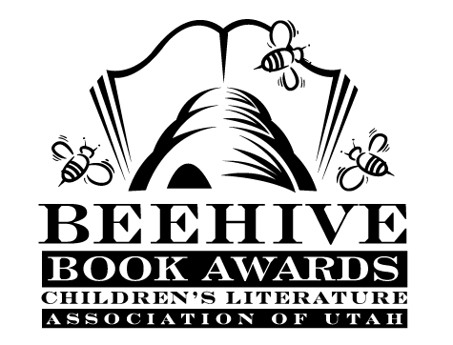

Children’s Fiction Books—Beehive Nominees 2012

- (Winner) Out of My Mind by Sharon Draper
- Because of Mr. Terupt by Rob Buyea
- The Best Bad Luck I Ever Had by Kristin Levine
- Clockwork Three by Matthew J. Kirby
- Emily’s Fortune by Phyllis Reynolds Naylor
- Lincoln and His Boys by Rosemary Wells
- The Mysterious Howling by Maryrose Wood
- Palace Beautiful by Sarah DeFord Williams
- The Strange Case of Origami Yoda by Tom Angleberger
- Wild Girl by Patricia Reilly Giff

Picture Books—Beehive Nominees 2012

- (Winner) Shark vs. Train by Chris Barton and Tom Lichtenheld
- All the World by Liz Garton Scanlon and Marla Frazee
- Brontorina by James Howe and Randy Cecil
- Chalk by Bill Thomson
- City Dog, Country Frog by Mo Willems and Jon J. Muth
- Clever Jack Takes the Cake Candace Fleming and G. Brian Karas
- The Cow Loves Cookies by Karma Wilson and Marcellus Hall
- Princess Hyacinth (The Surprising Tale of a Girl Who Floated) by Florence Parry
- Heide and Lane Smith
- A Small Brown Dog With a Wet Pink Nose by Stephanie Stuve-Bodeen and Linzie
Hunter
- Spells by Emily Gravett

Informational Books—Beehive Nominees 2012

- (Winner) Candy Bomber: The Story of the Berlin Airlift’s “Chocolate Pilot” by Michael O.
Tunnell
- Bones: Skeletons and How They Work by Steve Jenkins
- Case Closed? : Nine Mysteries Unlocked by Modern Science by Susan Hughes
- The Extraordinary Mark Twain (According To Susy) by Barbara Kerley
- The Great and Only Barnum: The Tremendous, Stupendous Life of Showman P.T.
Barnum by Candace Fleming
- Neo Leo: The Ageless Ideas of Leonardo da Vinci by Gene Barretta
- Nic Bishop Lizards by Nic Bishop
- The War to End All Wars: World War I by Russell Freedman
- Written in Bone: Buried Lives of Jamestown and Colonial Maryland by Sally M.
Walker
- Animals Up Close by Igor Siwanowicz

Poetry Books—Beehive Nominees 2012

- (Winner) The Dancing Pancake by Ellen Spinelli
- A Curious Collection of Cats: Concrete Poems by Betsy Franco
- Curious Creatures: Animal Poems by Barry Louis Polisar
- Dark Emperor and Other Poems of the Night by Joyce Sidman
- Dizzy in Your Eyes: Poems about Love by Pat Mora
- In the Wild by David Elliott
- Mirror Mirror: A Book of Reversible Verse by Marilyn Singer
- Name That Dog: Puppy Poems from A to Z by Peggy Archer
- Scarum Fair by Jessica Swaim
- Spot the Plot: A Riddle Book of Book Riddles by Patrick J. Lewis

Young Adult Fiction Books—Beehive Nominees 2012

- (Winner) Dragonfly by Julia Golding
- After Ever After by Jordan Sonnenblick
- Birthmarked by Caragh M. O’Brien
- Bruiser by Neal Shusterman
- Boy Who Dared Susan Campbell Bartoletti
- Dark Life by Kat Falls
- Heist Society by Ally Carter
- The Hunchback Assignments Arthur G. Slade
- Mirrorscape by Mike Wilks
- A Spy in the House by Ling S. Lee
- Three Rivers Rising by Jame Richards
- The Wide-Awake Princess by E. D. Baker

