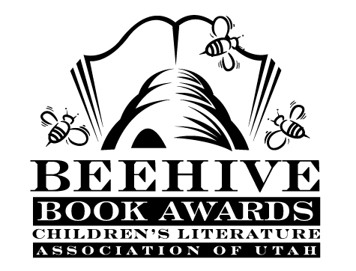
Children’s Fiction Books—Beehive Nominees 2011

- (Winner) Where the Mountain Meets the Moon by Grace Lin
- 11 Birthdays by Wendy Mass
- The Adventurous Deeds of Deadwood Jones by Helen Hemphill
- Binky the Space Cat (A Binky Adventure) by Ashley Spires
- The Evolution of Calpurnia Tate by Jacqueline Kelly
- Extra Credit by Andrew Clements; illustrated by Mark Elliott
- The Leanin' Dog by K.A. Nuzum
- Me and the Pumpkin Queen by Marianne Kennedy
- Mudville by Kurtis Scaletta
- The Year the Swallows Came Early by Kathryn Fitzmaurice

Picture Books—Beehive Nominees 2011
- (Winner) Duck! Rabbit! by Amy Krouse Rosenthal; illustrated by Tom Lichtenheld
- The Apple-Pip Princess by Jane Ray
- Birds by Kevin Henkes; illustrated by Laura Dronzek
- That Book Woman by Heather Henson; illustrated by David Small
- Chicken Cheeks by Michael Ian Black; illustrated by Kevin Hawkes
- The Circus Ship by Chris Van Dusen
- Higher! Higher! by Leslie Patricelli
- Just What Mama Needs by Sharlee Mullins Glenn; illustrated by Amiko Hirao
- Most Loved In All the World by Tonya Cherie Hegamin; illustrated by Cozbi Cabrera
- Tsunami by Kimiko Kajikawa; illustrated by Ed Young

Informational Books—Beehive Nominees 2011

- (Winner) Frogs by Nic Bishop
- 14 Cows for America by Carmen Agra Deedy; illustrated by Thomas Gonzalez
- Almost Astronauts: 13 women Who Dared to Dream by Tanya Lee Stone
- The Boy Who Invented TV: The Story of Philo Farnsworth by Kathleen Krull; illustrated by Greg Couch
- Darwin by Alice McGinty; illustrated by Mary Azarian
- Down, Down, Down: a Journey to the Bottom of the Sea by Steve Jenkins
- George Washington Carver by Tonya Bolden
- A Life in the Wild: George Shaller's Struggle to Save the Last Great Beasts by Pamela S. Turner
- Mermaid Queen: the Spectacular True Story of Annette Kellerman,
Who swam her Way to Fame, Fortune & Swimsuit History by Shana Corey
- You Never Heard of Sandy Koufax?! by Jonah Winter; illustrated by Andre Carriho

Poetry Books—Beehive Nominees 2011

- (Winner) The Bill Martin Jr. Big Book of Poetry edited by Bill Martin Jr. and Michael Sampson
- Be Glad Your Nose is on Your Face and Other Poems: Some of the Best of Jack Prelutsky by Jack Prelutsky; illustrated by Brandon Dorman
- Button Up!: Wrinkled Rhymes by Alice Schertle; illustrated by Petra Mathers
- Dinothesaurus: Prehistoric Poems and Paintings by Douglas Florian
- Far From You by Lisa Schroeder
- A Fuzzy-Fast Blur: Poems about Pets by Laura Purdie Salas
- Partly Cloudy: Poems of Love and Longing by Gary Soto
- Truckery Rhymes by Jon Scieska; illustrated by David Shannon, Loren Long, and David Gordon
- The Underwear Salesman: and Other Jobs for Better or Verse by J. Patrick Lewis; illustrated by Serge Bloch
- A Whiff of Pine, a Hint of Skunk: a Forest of Poems by Deoborah Ruddell; illustrated by Joan Rankin

Young Adult Fiction Books—Beehive Nominees 2011

- (Winner) Princess of the Midnight Ball by Jessica Day George
- Along for the Ride by Sarah Dessen
- Brooklyn Nine: A Novel in Nine Innings by Alan Gratz
- The Chosen One: A Novel by Carol Lynch Williams
- Chains (Seeds of America, book 1) by Laurie Halse Anderson
- The Compound by S.A. Bodeen
- The Devil's Paintbox by Victoria McKernan*
- Eon (Dragoneye Reborn, book 1) by Alison Goodman*
- Flygirl by Sherri L. Smith
- The Musician's Daughter by Susanne Emily Dunlap
- My Fair Godmother by Janette Rallison
- Project Sweet Life by Brent Hartinger
*mature readers

