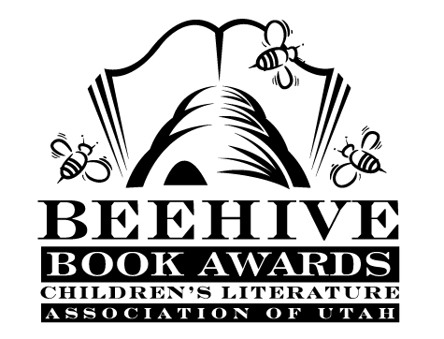
Children’s Fiction Books—Beehive Nominees 2010

- (Winner) The Magic Thief (The Magic Thief, book 1) by Sarah Prineas
- The Big Field by Mike Lupica
- The Cabinet of Wonders (The Kronos Chronicles, book 1) by Marie Rutkoski
- A Crooked Kind of Perfect by Linda Urban
- Emma-Jean Lazarus Fell Out of a Tree by Lauren Tarshis
- The Girl Who Could Fly by Victoria Forester
- Middle School is Worse than Meatloaf: a Year Told Through Stuff by Jennifer L. Holm; illustrated Elicia Castaldi
- The Mysterious Benedict Society (The Mysterious Benedict Society, book 1) by Trenton Lee Stewart; illustrated by Carson Ellis
- Night of the Howling Dogs by Graham Salisbury
- Someone Named Eva by Joan M. Wolf

Picture Books—Beehive Nominees 2010

- (Winner) When Dinosaurs Came With Everything by Elise Broach; illustrated by David Small
- The Black Book of Colors by Menena Cottin; illustrated by Rosana Faria; translated by Elisa Amado
- The Chicken of the Family by Mary Amata; illustrated by Delphine Durand
- The Cow that Laid an Egg by Andy Cutbill; illustrated by Russell Ayto
- The End by David LaRochelle; illustrated by Richard Egielski
- I Am Invited to a Party! (An Elephant and Piggie Book) by Mo Willems
- Louder, Lili by Gennifer Choldenko; illustrated by S.D. Schindler
- Mary Had a Little Lamp by Jack Lechner; illustrated by Bob Staake
- My Travelin' Eye by Jenny Sue Kostecki-Shaw
- South by Patrick McDonnell

Informational Books—Beehive Nominees 2010

- (Winner) How Big Is It?: a Big Book all About Bigness by Ben Hillman
- 11 Planets: a New View of the Solar System by David A. Aguilar
- Boys of Steel: the Creators of Superman by Marc Tyler Nobleman; illustrated by Ross MacDonald
- Manfish: a Story of Jacques Cousteau by Jennifer Berne; illustrated by Eric Puybaret
- Spiders by Nic Bishop
- Seven Miles to Freedom: the Robert Smalls Story by Janet Halfmann; illustrated by Duane Smith
- Sisters & Brothers: Sibling Relationships in the Animal World
by Steve Jenkins and Robin Page
- Two Bobbies: a True Story of Hurricane Katrina, Friendship, and Survival
by Kirby Larson and Mary Nethery; illustrated by Jean Cassels
- We are the Ship: the Story of Negro League Baseball by Kadir Nelson
- What to Do About Alice?: How Alice Roosevelt Broke the Rules, Charmed the World, and Drove Her Father Teddy Crazy! by Barbara Kerley; illustrated by Edwin Fotheringham

Poetry Books—Beehive Nominees 2010

- (Winner) Oh, Theodore!: Guinea Pig Poems by Susan Katz; illustrated by Stacey Schuett
- 42 Miles by Tracie Vaughn Zimmer; illustrated by Elaine Clayton
- Crocs! by David T. Greenberg; illustrated by Lynn Munsinger
- Frankenstein Takes the Cake by Adam Rex
- Imaginary Menagerie: a Book of Curious Creatures by Julie Larios; illustrated by Julie Paschkis
- M is for Mischief: An A to Z of Naughty Children by Linda Ashman; illustrated by Nancy Carpenter
- Oops! by Alan Katz; illustrated Edward Koren
- Pizza, Pigs and Poetry: How to Write a Poem by Jack Prelutsky
- A River of Words: the Story of William Carlos Williams by Jen Bryant ; illustrated by Melissa Sweet
- This Is Just to Say: Poems of Apology and Forgiveness by Joyce Sidman; illustrated by Pamela Zagarenski

Young Adult Fiction Books—Beehive Nominees 2010

- (Winner) The Hunger Games (The Hunger Games, book 1) by Suzanne Collins*
- Airman by Eoin Colfer
- Beastly by Alex Flinn*
- Book of a Thousand Days by Shannon Hale
- Climbing the Stairs by Padma Venkatraman
- Evolution, Me & Other Freaks of Nature by Robin Brande
- House of Many Ways by Diana Wynne Jones
- Schooled by Gordon Korman
- Shift by Jennifer Bradbury
- Sun and Moon, Ice and Snow by Jessica Day George
- Unwind by Neal Shusterman*
- Waiting for Normal by Leslie Connor
*mature readers

