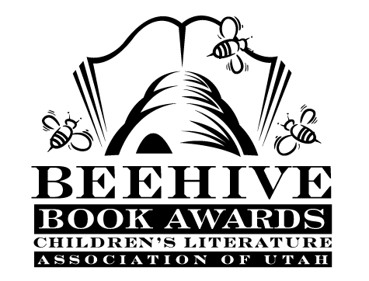
Children’s Fiction Books—Beehive Nominees 2009

- (Winner) The Candy Shop War by Brandon Mull
- The Aurora County All-Stars by Deborah Wiles
- Clementine by Sara Pennypacker; illustrated by Marla Frazee
- Dragon Slippers by Jessica Day George
- Houndsley and Catina by James Howe; illustrated by Marie-Louise Gay
- No Talking by Andrew Clements; illustrated by Mark Elliott
- On the Wings of Heroes by Richard Peck
- Paint the Wind by Pam Munoz Ryan
- Rules by Cynthia Lord
- Way Down Deep by Ruth White

Picture Books—Beehive Nominees 2009

- (Winner) If I Built a Car by Chris Van Dusen
- Adèle & Simon by Barbara McClintock
- Black? White! Day? Night!: A Book of Opposites by Laura Vaccaro Seeger
- The Boy Who was Raised by Librarians by Carla Morris; illustrated by Brad Sneed
- Coming On Home Soon by Jacqueline Woodson; illustrated by E.B. Lewis
- The Incredible Book-Eating Boy by Oliver Jeffers
- Knuffle Bunny Too: A Case of Mistaken Identity by Mo Willems
- Not Norman: a Goldfish Story by Kelly Bennett; illustrated by Noah Z. Jones
- Un-Brella by Scott E. Franson
- Would I Ever Lie to You? by Caralyn Buehner; illustrated by Jack E. Davis

Informational Books—Beehive Nominees 2009

- (Winner) The Dangerous Book for Boys by Conn Iggulden and Hal Iggulden
- Dogs and Cats by Steve Jenkins
- Freedom Walkers: The Story of the Montgomery Bus Boycott by Russell Freedman
- It's a Butterfly's Life by Irene Kelly
- John Muir: America's First Environmentalist by Kathryn Lasky; illustrated by Stan Fellows
- Oh Rats! The Story of Rats and People by Albert Marrin; illustrated by C.B. Mordan
- Onward: the Photobiography of African-American Polar Explorer Matthew Henson by Dolores Johnson
- Quest for the Tree Kangaroo: an Expedition to the Cloud Forest of New Guinea by Sy Montgomery; photography by Nic Bishop
- To Dance: a Ballerina's Graphic Novel by Siena Cherson Siegel; illustrated by Mark Siegel
The Wall: Growing up Behind the Iron Curtain by Peter Sis

Poetry Books—Beehive Nominees 2009

- (Winner) Dogku by Andrew Clements; illustrated by Tim Bowers
- Blue Lipstick: Concrete Poems by John Grandits
- Bugs: Poems about Creeping Things by David L. Harrison; illustrated by Rob Shepperson
- Comets, Stars, the Moon and Mars: Space Poems and Paintings by Douglas Florian
- Cowlick! by Christin Ditchfield; illustrated by Rosalind Beardshaw
- Good Sports: Rhymes about Running, Jumping, Throwing and More by Jack Prelutsky; illustrated by Chris Raschka
- Here's a Little Poem: A Very First Book of Poetry by Jane Yolen and Andrew Fusek Peters; illustrated by Polly Dunbar
- Mother Goose: Numbers on the Loose by Leo & Diane Dillon
- The Snack Smasher: And Other Reasons Why It's Not My Fault by Andrea Perry; illustrated by Alan Snow
- Where I Live by Eileen Spinelli; illustrated by Matt Phelan

Young Adult Fiction Books—Beehive Nominees 2009

- (Winner) Wildwood Dancing by Juliet Marillier
- The Case of the Left-Handed Lady: an Enola Holmes Mystery (Enola Holmes Mystery, book 2) by Nancy Springer
- Epic by Conor Kostick
- Fight Game by Kate Wild
- Hot Lunch by Alex Bradley
- It's a Mall World After All by Janette Rallison
- Kiki Strike: Inside the Shadow City (Kiki Strike, book 1) by Kirsten Miller
- The King of Attolia (The Queen’s Thief, book 3) by Megan Whalen Turner
- Life As We Knew It (Life As We Knew It, book 1) by Susan Beth Pfeffer
- Pigboy (Orca Currents) by Vicki Grant
- Red Moon at Sharpsburg by Rosemary Wells
- The Wednesday Wars by Gary D. Schmidt

