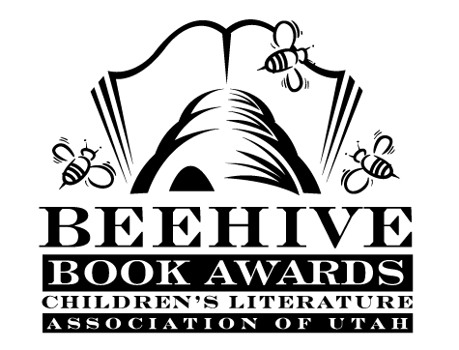
Children’s Fiction Books—Beehive Nominees 2008

- (Winner) The Miraculous Journey of Edward Tulane by Kate DiCamillo; illustrated by Bagram Ibatoulline
- Bella at Midnight by Diane Stanley; illustrated by Bagram Ibatoulline
- The Boy Who Saved Cleveland by James Cross Giblin; illustrated by Michael Dooling
- Fairest by Gail Carson Levine
- Fairy Tale Detectives (The Sisters Grimm, book 1 ) by Michael Buckley; illustrated by Peter Ferguson
- Hero Revealed (The Extraordinary Adventures of Ordinary Boy, book 1)
by William Boniface; illustrated by Stephen Gilpin
- Moose's Big Idea (Moose and Hildy, book 1) by Stephanie Greene; illustrated by Joe Mathieu
- Our Hero (Babymouse, book 2) by Jennifer Holm; illustrated by Matthew Holm
- Weedflower by Cynthia Kadohata
- Yellow Star by Jennifer Rozines Roy

Picture Books—Beehive Nominees 2008

- (Winner) Mommy? by Maurice Sendak, Arthur Yorinks and Matthew Reinhart
- Baby Brains: The Smartest Baby in the Whole World by Simon James
- Fancy Nancy by Jane O'Conner ; illustrated by Robin Preiss Glasser
- John, Paul, George, & Ben by Lane Smith
- Keeper of Soles by Teresa Bateman; illustrated by Yayo
- Library Lion by Michelle Knudsen; illustrated by Kevin Hawkes
- Mrs. Crump's Cat by Linda Smith; illustrated by David Roberts
- The Secret Science Project That Almost Ate the School by Judy Sierra illustrated by Stephen Gammell
- Tudley Didn't Know by John Himmelman
- The Witch's Walking Stick by Susan Meddaugh

Informational Books—Beehive Nominees 2008

- (Winner) What if You Met a Pirate? by Jan Adkins
- Children of the Great Depression by Russell Freedman
- An Egg is Quiet by Dianna Hutts Aston; illustrated by Sylvia Long
- Now & Ben: The Modern Inventions of Benjamin Franklin by Gene Barretta
- Guinea Pig Scientists: Bold Self-Experimenters in Science and Medicine by Mel Boring and Leslie Dendy; illustrated by C.B. Mordan
- Team Moon: How 400,000 People Landed Apollo 11 on the Moon by Catherine Thimmesh
- ER Vets: Life in an Animal Emergency Room by Donna M. Jackson
- Bodies from the Ash: Life and Death in Ancient Pompeii by James M. Deem
- Counting Coup: Becoming a Crow Chief on the Reservation and Beyond by Joseph Medicine Crow and Herman Viola
- Secrets of a Civil War Submarine: Solving the Mysteries of the H.L. Hunley by Sally M. Walker

Poetry Books—Beehive Nominees 2008

- (Winner) Once I Ate a Pie by Patricia MacLachlan, Emily MacLachlan Charest; illustrated by Katy Schneider
- The Barefoot Book of Classic Poems compiled and illustrated by Jackie Morris
- Behold the Bold Umbrellaphant: and Other Poems by Jack Prelutsky; illustrated by Carin Berger
- Busy in the Garden by George Shannon; illustrated by Sam Williams
- Frankenstein Makes a Sandwich by Adam Rex
- She's All That: Poems About Girls by Belinda Hollyer
- There is a Flower on the Tip of my Nose Smelling Me by Alice Walker; illustrated by Stefano Vitale
- Tour America: a Journey Through Poems and Art by Diane Siebert; illustrated by Stephen T. Johnson
- Yellow Elephant: a Bright Bestiary by Julie Larios; illustrated by Julie Paschkis

Young Adult Fiction Books—Beehive Nominees 2008

- (Winner) Bad Kitty by Michele Jaffe
- Alphabet of Dreams by Susan Fletcher
- Dairy Queen by Catherine Gilbert Murdock
- Extraordinary Adventures of Alfred Kropp (Alfred Kropp, book 1) by Richard Yancey
- Gideon the Cutpurse (title changed to The Time Travelers in later publications) (The Cutpurse Trilogy, book 1) by Linda Buckley-Archer
- Golden: a Retelling of Rapunzel (Once Upon a Time, book 5) by Cameron Dokey
- Hit the Road by Caroline B. Cooney
- The Lighthouse Land (The Lighthouse Trilogy, book 1) by Adrian McKinty
- The Light of the Oracle by Victoria Hanley
- Mimus by Lilli Thal and translated by John Brownjohn
- Pieces of Georgia by Jen Bryant
- The Rhyming Season by Edward Averett
- The Warrior Heir (The Heir Novels, book 1) by Cinda Williams Chima

