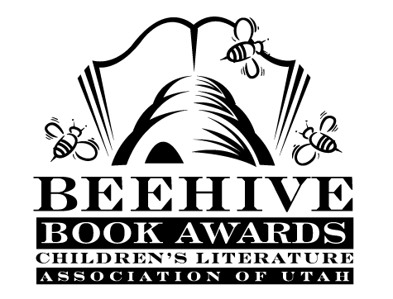
Children’s Fiction Books—Beehive Nominees 2006

- (Winner) Dragon Rider by Cornelia Funke
- Becoming Naomi Leon by Pam Munoz Ryan
- Chasing Vermeer by Blue Balliet; illustrated by Brett Helquist
- Fame and Glory in Freedom, Georgia by Barbara O'Connor
- Heartbeat by Sharon Creech
- Ida B: ...and Her Plans to Maximize Fun, Avoid Disaster and (Possibly) Save the World by Katherine Hannigan
- Measle and Wrathmonk by Ian Ogilvy
- Niagara Falls, or Does it? (Hank Zipzer, book 1) by Henry Winkler and Lin Oliver; illustrated by Jesse Joshua Watson
- The Postman Always Brings Mice (The Stink Files, book 1) by Holm & Hammel; illustrated by Brad Weinman
- Ruby Lu, Brave and True by Lenore Look; illustrated by Anne Wilsdorf
- The World According to Humphrey by Betty G.Birney

Picture Books—Beehive Nominees 2006

- (Winner) Some Dogs Do by Jex Alborough
- Falling for Rapunzel by Leah Wilcox; illustrated by Lydia Monks
- Knockin' on Wood: Starring Peg Leg Bates by Lynn Barasch
- Knuffle Bunny: a Cautionary Tale by Mo Willems
- My Teacher for President by Kay Winters; illustrated by Denise Brunkus
- The Printer by Myron Uhlberg; illustrated by Henri Sorensen
- Superdog: the Heart of a Hero by Caralyn Buehner; illustrated by Mark Buehner
- Unwitting Wisdom: An Anthology of Aesop's Fables by Helen Ward
- Up the Learning Tree by Marcia Vaughan; illustrated Derek Blanks
- Wild About Books by Judy Sierra and Marc Brown

Informational Books—Beehive Nominees 2006

- (Winner) Actual Size by Steve Jenkins
- Arctic Lights, Arctic Nights by Debbie S. Miller; illustrated by Jon Van Zyle
- The Boy on Fairfield Street: How Ted Geisel Grew Up to Become Dr. Seuss by Kathleen Krull; illustrated by Steve Johnson and Lou Fancher
- By My Brother's Side by Tiki Barber, Ronde Barber; illustrated by Barry Root
- Hana's Suitcase by Karen Levine
- The Man Who Went to the Far Side of the Moon: The Story of Apollo 11 Astronaut Michael Collins by Bea Uusma Schyffert
- On this Spot: An Expedition Back Through Time by Susan E. Goodman; illustrated by Lee Christiansen
- One Small Place in a Tree by Barbara Brenner; illustrated by Tom Leonard
- Seurat and La Grande Jatte by Robert Burleigh
- What Presidents are Made of by Hanoch Piven

Poetry Books—Beehive Nominees 2006

- (Winner) Rolling in the Aisles: a Collection of Laugh-out-loud Poems by Bruce Lansky; illustrated by Stephen Carpenter
- Because I Could Not Stop My Bike and Other Poems by Karen Jo Shapiro ; illustrated by Matt Faulkner
- BrainJuice: Science Fresh Squeezed! by Carol Diggory Shields; illustrated by Richard Thompson
- The Essential Worldwide Monster Guide by Linda Ashman; illustrated by David Small
- Jabberwocky by Lewis Carroll; illustrated by Joel Stewart
- My School's a Zoo! by Stu Smith; illustrated by David Catrow
- Rainbow Soup: Adventures in Poetry by Brian P. Cleary; illustrated by Neal Layton
- She'll Be Comin' Round the Mountain by Philemon Sturges
- Squeal and Squawk: Barnyard Talk by Susan Pearson; illustrated by David Slonim
- A Sock is a Pocket for Your Toes: a Pocket Book by Elizabeth Garton Scanlon; illustrated by Robin Preiss Glasser
- Tai Chi Morning: Snapshots of China by Nikki Grimes; illustrated by Ed Young
- Wild Wings: Poems for Young People by Jane Yolen; photography by Jason Stemple

Young Adult Fiction Books—Beehive Nominees 2006

- (Winner) Airborn (Airborn, book 1) by Kenneth Oppel
- Heir Apparent by Vivian Vande Velde
- The Last Chance Texaco by Brent Hartinger
- Milkweed by Jerry Spinelli
- Mississippi Trail, 1955 by Chris Crowe
- Overboard by Elizabeth Fama
- The Secret Hour (Midnighters, book 1) by Scott Westerfeld
- Shadow of a Doubt by S.L. Rottman
- Taylor Five by Ann Halam
- The Truth About Forever by Sarah Dessen
- The Wee Free Men (Discworld, book 1) by Terry Pratchett
- Wishing Moon by Michael O. Tunnell

