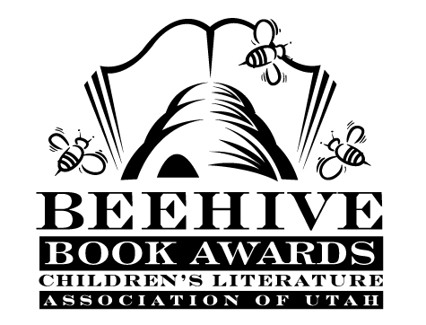
Children’s Fiction Books—Beehive Nominees 2005

- (Winner) The City of Ember (The Books of Ember, book 1) by Jeanne DuPrau
- The Field Guide (The Spiderwick Chronicles, book 1)
by Tony DiTerlizzi and Holly Black
- Flipped by Wendelin Van Draanen
- Granny Torrelli Makes Soup by Sharon Creech
- Gregor the Overlander (The Underland Chronicles, book 1) by Suzanne Collins
- Inkheart (Inkheart, book 1) by Corneila Funke
- Maggie's Door by Patricia Reilly Giff
- Midnight for Charlie Bone (Children of the Red King, book 1) by Jenny Nimmo
- Molly Moon's Incredible Book of Hypnotism by Georgia Byng
- The One Eyed-Giant (Mary Pope’s Tales of the Odyssey, book 1) by Mary Pope Osborne; illustrations by Tony Howell
Rodzina by Karen Cushman

Picture Books—Beehive Nominees 2005

- (Winner) Diary of a Worm by Doreen Cronin
- The Elves and the Shoemaker by Jacob Grimm and Jim LaMarche
- How I Became a Pirate by Melinda Long; illustrated by David Shannon
- I Know a Rhino by Charles Fuge
- King Midas and the Golden Touch by Charlotte Craft; illustrated by Kinuko Y. Craft
- Late For School by Mike Reiss; illustrated by Michael Austin
- Mary Smith by Andrea U'Ren
- Noah's Ark by Jerry Pinkney
- One Dark Night by Lisa Wheeler; illustrated by Ivan Bates
- Secret Remedy Book: the Story Of Comfort and Love by Karin Cates

Informational Books—Beehive Nominees 2005

- (Winner) How Angel Peterson Got His Name by Gary Paulsen
- A is for Arches : a Utah Alphabet by Becky Hall; illustrated by Katherine Larson
- Fields of Fury : The American Civil War by James M. McPherson
- Hero Dogs : Couragous Canines in Action by Donna M. Jackson
- Ladybugs : Red, Fiery and Bright by Mia Posada
- Muhammad by Demi
- New Dinos : The Latest Finds! The Coolest Dinosaur Discoveries! by Shelly Tanaka; illustrated by Alan Barnard
- Pond by Gordan Morrison
- Secrets of the Deep Revealed by Frances Dipper
- To the Top: The Story of Everest by Stephen Venables

Poetry Books—Beehive Nominees 2005

- (Winner) Giant Children by Brod Bagert ; illustrated by Tedd Arnold
- Dear Mother, Dear Daughter: Poems for Young People by Jane Yolen and Heidi E. Y. Stemple; illustrated by Gil Ashby
- Exploding Gravy : Poems to Make You Laugh by X.J. Kennedy ; illustrated by Joy Allen
- In the Spin of Things: Poetry of Motion by Rebecca Kai Dotlich ; illustrated by Karen Dugan
- Locomotion by Jacqueline Woodson
- Plum by Tony Mitton
- Spider and the Fly by Mary Howitt; illustrated by Tony DiTerlizzi
- This is the House That Jack Built by Simms Taback
- Whisper and Shout: Poems to Memorize by Patrice Vecchione

Young Adult Fiction Books—Beehive Nominees 2005

- (Winner) Eragon (Inheritance, book 1) by Christopher Paolini
- Cheating Lessons by Nan Willard Cappo
- East by Edith Pattou
- For Freedom: The Story of a French Spy by Kimberly Brubaker Bradley
- Full Tilt by Neal Shusterman
- Girl in a Cage (Stuart Quartet, book 2) by Jane Yolen
- The Goose Girl by Shannon Hale
- Kite Rider by Geraldine McCaughrean
- Red Midnight by Ben Mikaelsen
- Search on the Moon King's Daughter by Linda Holeman
- Son of the Mob by Gordan Korman

