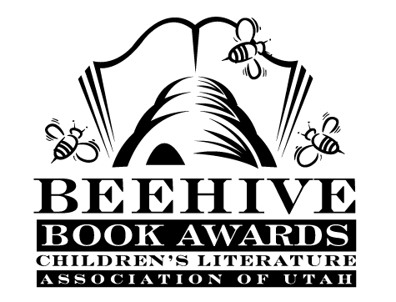
Children’s Fiction Books—Beehive Nominees 2004

- (Winner) Ruby Holler by Sharon Creech
- Angel on the Square by Gloria Whelan
- Charlotte's Rose by A. E. Cannon
- Gooney Bird Greene by Lois Lowry
- Journey to the River Sea by Eve Ibbotson, illustrated by Kevin Hawkes
- Pictures of Hollis Woods by Patricia Reilly Giff
- Riding Freedom by Pam Munoz Ryan
- Rowan of Rin (Rowan of Rin, book 1) by Emily Rodda
- The Thief Lord by Cornelia Funke; illustrated by Christian Birmingham
- When My Name was Keoko by Linda Sue Park

Picture Books—Beehive Nominees 2004

- (Winner) Bertie Was a Watchdog by Rick Walton
- A Quiet Place by Douglas Wood ; illustrated Dan Andreasen
- Dear Mrs. LaRue: Letters from Obedience School by Mark Teague
- Gleam and Glow by Eve Bunting ; illustrated by Peter Sylvada
- The Great Show-and-Tell Disaster by Mike Reiss; illustrated by Mike Cressy
- Hip, Hip, Hooray for Annie McRae by Brad Wilcox; illustrated by Julie Olson
- The Magic Hat by Mem Fox; illustrated by Tricia Tusa
- Ordinary Mary's Extraordinary Deed by Emily Pearson; illustrated by Fumi Kosaka
- The Other Side by Jacqueline Woodson; illustrated by E.B. Lewis
- School Picture Day by Lynn Plourde; illustrated by Thor Wickstrom
- Smile A Lot! by Nancy L. Carlson
- Snowmen at Night by Carolyn Buehner; illustrated by Mark Buehner
- What's the Time, Grandma Wolf? by Ken Brown

Informational Books—Beehive Nominees 20

- (Winner) Leonardo's Horse by Jean Fritz; illustrated by Hudson Talbott
- Abraham Lincoln by Amy L. Cohn, Suzy Schmidt, and David A. Johnson
- The Cod's Tale by Mark Kurlansky; illustrated by S.D. Schindler
- The Dinosaurs of Waterhouse Hawkins by Barbara Kerley; illustrated by Brian Selznick
- The Emperor's Silent Army: Terracotta Warriors of Ancient China by Jane O'Connor
- Fannie in the Kitchen by Deborah Hopkinson; illustrated by Nancy Carpenter
- Mercedes and the Chocolate Pilot by Margot Theis Raven
- Sharkabet by Ray Troll and American Museum of Natural History
- Chocolate: Riches from the Rainforest by Robert Burleigh
- Encantado: Pink Dolphin of the Amazon by Sy Montgomery; photographs by Dianne Taylor-Snow

Poetry Books—Beehive Nominees 2004

- (Winner) The Moon & Riddles Diner and the Sunnyside Cafe by Nancy Willard; illustrated by Chris Butler
- 100 Best Poems of All Time by Leslie Pockell
- Cool Melons-Turn to Frogs!: The Life and Poems of Issa by Matthew Gollub; illustrated by Kazuko G. Stone
- Fly with Poetry: an ABC of Poetry by Avis Harley
- Monster Goose by Judy Sierra; illustrated by Jack E. Davis
- Silver Seeds by Paul Paolilli and Dan Brewer; paintings by Steve Johnson and Lou Fancher
- Wool Gathering: a Sheep Family Reunion by Lisa Wheeler; paintings by Frank Ansley

Young Adult Fiction Books—Beehive Nominees 2004

- (Winner) Stormbreaker (Alex Rider Adventure, book 1) by Anthony Horowitz
- Battle Dress by Amy Efaw
- Bronx Masquerade by Nikki Grimes
- Goddess of Yesterday by Caroline B. Cooney
- The House of the Scorpion by Nancy Farmer
- Lord of the Nutcracker Men by Iain Lawrence
- Once Upon a Marigold by Jean Ferris
- Stetson by S.L. Rottman
- Things Not Seen by Andrew Clements
- What My Mother Doesn't Know by Sonya Sones

