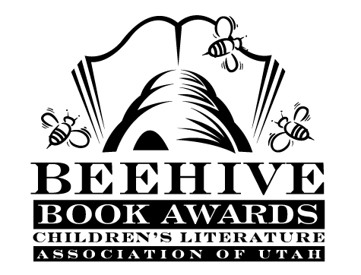
Children’s Fiction Books—Beehive Nominees 2003

- (Winner) Two Princesses of Bamarre by Gail Carson Levine
- Beany and the Dreaded Wedding by Susan Wojciechowski; illustrated by Susanna Natti
- Frankenbug by Steven Cousins
- Gold Dust by Chris Lynch
- Jack Black and the Ship of Thieves by Carol Hughes
- Judy Moody (Judy Moody, book 1) by Megan McDonald; illustrated by Peter H. Reynolds
- The Last Lobo by Roland Smith
- Love, Ruby Lavender by Deborah Wiles
- The School Story by Andrew Clements; illustrated by Brian Selznick
- Silent Thunder by Andrea Davis Pinkney
- Trial by Journal by Kate Klise and M. Sarah Klise

Picture Books—Beehive Nominees 2003

- (Winner) Stand Tall, Molly Lou Melon by Patty Lovell; illustrated David Catrow
- Albert by Donna Jo Napoli; illustrated by Jim LaMarche
- Celebrate the Fire Within by Kathy Larsen
- Coolies by Yin; illustrated by Chris Soentpiet
- Don't Need Friends by Carolyn Crimi
- Eat Your Peas by Kes Gray; illustrated by Nick Sharratt
- Enemy Pie by Derek Munson; illustrated by Tara Calahan King
- Hog Music by Mary-Claire Helldorfer
- More Parts by Tedd Arnold
- The Name Jar by Yangsook Choi
- Ted by Tony DiTerlizzi
- Wait! No Paint! by Bruce Whatley

Informational Books—Beehive Nominees 2003

- (Winner) Tiger Math : Learning to Graph from a Baby Tiger by Ann Whitehead Nagda and Cindy Bickel
- Food Rules! The Stuff You Munch, It's Crunch, It's Punch, and Why You Sometimes Lose Your Lunch by Bill Haduch; illustrated by Rick Stromoski
- Give Me Liberty!: The Story of the Declaration of Independence by Russell Freedman
- The Good Fight: How World War II Was Won by Stephen E. Ambrose
- Hidden Worlds: Looking Through a Scientist's Microscope by Stephen Kramer; photographs by Dennis Kunkel
- Hmm? The Most Interesting Book You'll Ever Read About Memory by Diane Swanson; illustrated by Rose Cowles
- Michelangelo by Diane Stanley
- Shipwrecked!: The True Adventures of a Japanese Boy by Rhoda Blumberg
- Tomboy of the Air: Daredevil Pilot Blanche Stuart Scott by Julie Cummins
- What Can You Do with a Paper Bag? by Judith Cressy, Maria Quiroga, Christine Butler, Edward Heins, and The Metropolitan Museum of Art

Poetry Books—Beehive Nominees 2003

- (Winner) Take Me Out of the Bathtub and Other Silly Dilly Songs by Alan Katz; illustrated by David Catrow
- It’s Raining Pigs and Noodles by Jack Prelutsky; illustrated by James Stevenson
- The Paper Doorway: Funny Verse and Nothing Worse by Dean Koontz
- A Poke in the I: a Collection of Concrete Poems edited by Paul B. Janeczko; illustrated by Chris Raschka

Young Adult Fiction Books—Beehive Nominees 2003

- (Winner) Touching Spirit Bear by Ben Mikaelsen
- Esperanza Rising by Pam Munoz Ryan
- Fever 1793 by Laurie Halse Anderson
- Goose Chase by Patrice Kindl
- Homeless Bird by Gloria Whelan
- Hope was Here by Joan Bauer
- The Last Book in the Universe by Rodman Philbrick
- The Seer and the Sword by Victoria Hanley
- Stuck in Neutral by Terry Trueman

