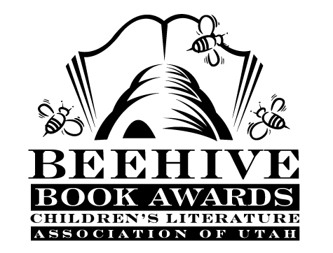
Children’s Fiction Books—Beehive Nominees 2002

- (Winner) Midnight Magic by Avi
- Adaline Falling Star by Mary Pope Osborne
- Alida's Song by Gary Paulsen
- Alien for Rent by Betsy Duffey; illustrated by Abby Carter
- Cinderellis and the Glass Hill (The Princess Tales, book 4) by Gail Carson Levine; illustrated by Mark Elliott
- The Janitor's Boy by Andrew Clements, illustrated by Brain Selznick
- My Brother Made Me Do It by Peg Kehret
- Song of the Wanderer (The Unicorn Chronicles, book 2) by Bruce Coville
- Surviving Brick Johnson by Laurie Myers
- The Water Horse by Dick King-Smith; illustrated by David Parkins
- The Word Eater by Mary Amato, illustrated by Christopher Ryniak
- The Year of Miss Agnes by Kirkpatrick Hill

Picture Books—Beehive Nominees 2002

- (Winner) Sitting Ducks by Michael Bedard
- The Butterfly by Patricia Polacco
- Click, Clack, Moo : Cows That Type by Doreen Cronin; illustrated by Betsy Lewin
- Henry Hikes to Fitchburg by D. B. Johnson
- My Monster Mama Loves Me So by Laura Leuck; illustrated by Mark Buehner
- Raising Sweetness by Diane Stanley
- Sector 7 by David Wiesner
- Tacky and the Emperor (Tacky the Penguin, bk. 4) by Helen Lester; illustrated by Lynn Munsinger
- Wemberly Worried by Kevin Henkes
- The Worrywarts by Pamela Duncan Edwards; illustrated Henry Cole
Informational Books—Beehive Nominees 2002

- (Winner) The Snake Scientist by Sy Montgomery; photographs by Nic Bishop
- After the Spill: The Exxon Valdez Disaster, Then and Now by Sandra Markle
- The Amazing Life of Benjamin Franklin by James Giblin
- The Genius of Leonardo by Guido Visconti; illustrated by Bimba Landmann
by James Giblin; illustrated by Michael Dooling
- Liberty by Lynn Curlee
- The Mystery of the Mammoth Bones and How It Was Solved by James Giblin
- The Perilous Journey of the Donner Party by Marian Calabro
- The Story of the Incredible Orchestra: An Introduction to the Musical Instruments and the Symphony Orchestra by Bruce Koscielniak
- The Top of the World: Climbing Mount Everest by Steve Jenkins
- You Forgot Your Skirt, Amelia Bloomer by Shana Corey; illustrated by Chesley McLaren

Poetry Books—Beehive Nominees 2002

- (Winner) Insectlopedia poems and paintings by Douglas Florian
- A Lucky Thing by Alice Schertle
- The Disappearing Alphabet by Richard Willbur; David Diaz
- Stone Bench in an Empty Park by Paul Janeczko; illustrated by Henri Silberman
- What Have You Lost? by Naomi Shihab Nye

Young Adult Fiction Books—Beehive Nominees 2002

- (Winner) Downsiders by Neal Schusterman
- A Wolf at the Door and Other Retold Fairy Tales by Ellen Datlow and Terri Windling
- A Dance for Three by Louise Plummer
- The Horizontal Man (Finnegan Zwake Mysteries, book 1) by Michael Dahl
- In My Enemy's House by Carol Matas
- Mary, Bloody Mary by Carolyn Meyer
- Night Hoops by Carl Deuker
- Oy Joy! by Lucy Frank
- Skellig by David Almond
- Stargirl by Jerry Spinelli
- Stop Pretending : What Happened When My Big Sister Went Crazy by Sonya Sones
- What Became of Her by M. E. Kerr

