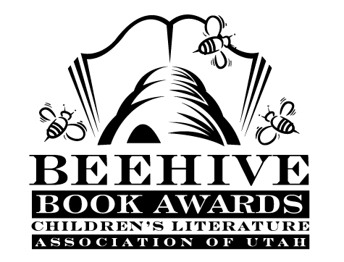
Children’s Fiction Books—Beehive Nominees 2001

- (Winner) The Secret of Platform 13 by Eva lbbotson
- Choosing Up Sides by John H. Ritter
- Eye of the Great Bear by Bill Wallace
- I'm Not Who You Think I Am by Peg Kehret
- The Kidnappers: A Mystery by Willo Davis Roberts
- Nowhere to Call Home by Cynthia C. DeFelice
- Our Only May Amelia by Jennifer L. Holm
- Perloo the Bold by Avi
- Sammy Keyes and the Hotel Thief (Sammy Keyes, book 1) by Wendelin Van Draanen
- Sasquatch by Roland Smith
- Well Wished by Franny Billingsley, illustrated by Leonid Gore
- When the Soldiers Were Gone by Vera W. Propp

Picture Books—Beehive Nominees 2001

- (Winner) Hooway for Wodney Wat by Helen Lester; illustrated by Lynn Munsinger
- Ed and Fred Flea by Pamela Duncan Edwards; illustrated by Henry Cole
- Farmer Brown Goes Round and Round by Teri Sloat; illustrated by Nadine Bernard Westcott
- Midnight Fridge by Bruce S. Glassman; illustrated by Brian Lies
- The Quiltmaker's Gift by Jeff Brumbeau; illustrated by Gail De Marcken
- Tell Me Something Happy Before I go to Sleep by Joyce Dunbar
- Tomas and the Library Lady by Pat Mora; illustrated by Raul Colon
- Weslandia by Paul Fleischman; illustrated by Kevin Hawkes
- What! Cried Granny: An Almost Bedtime Story by Kate Lum; illustrated by Adrian Johnson
- The Wolf is Coming! by Elizabeth MacDonald; illustrated by Ken Brown

Informational Books—Beehive Nominees 2001

- (Winner) If You Hopped Like a Frog by David Schwartz; illustrated by James Warhola
- Exploding Ants: Amazing Facts About How Animals Adapt by Joanne Settel
- Gargoyle on the Roof by Jack Prelutsky; illustrated by Peter Sis
- The History of Counting by Denise Schmandt-Besserat; illustrated by Michael Hays
- Rimshots : Basketball Pix, Rolls, and Rhythm by Charles R. Smith
- Shipwreck at the Bottom of the World : The Extraordinary True Story of Shackleton and the Endurance by Jennifer Armstrong
- To Everything There Is a Season by Leo and Diane Dillon
- Turn of the Century by Ellen Jackson; illustrated by Jan Davey Ellis
- What You Never Knew about Fingers, Forks, and Chopsticks by Patricia Lauber; illustrated by John Manders
- William Shakespeare & the Globe by Aliki

Young Adult Fiction Books—Beehive Nominees 2001

- (Winner) A Long Way from Chicago: A Novel in Stories by Richard Peck
- Armageddon Summer by Jane Yolen
- Dark Side of Nowhere by Neal Shusterman
- For Mike by Shelley Sykes
- Hidden Talents by David Lubar
- Maze by Will Hobbs
- Peeling the Onion by Wendy Orr
- Rough Waters by S.L. Rottman
- Seedfolks by Paul Fleischman
- Shadow Spinner by Susan Fletcher
- Soldier's Heart: Being the Story of the Enlistment and Due Service of the Boy Charley Goddard in the First Minnesota Volunteers by Gary Paulsen
- Under A Different Sky by Deborah Savage

