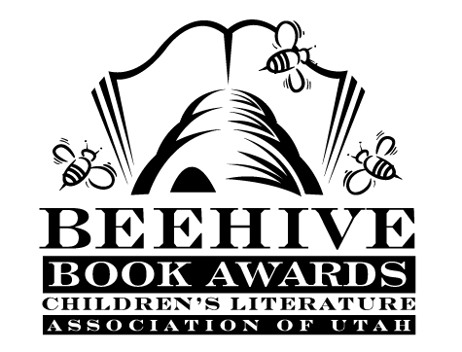
Children’s Fiction Books—Beehive Nominees 2000

- (Winner) Frindle by Andrew Clements
- Among the Hidden (Shadow Children, book 1) by Margaret Peterson Haddix
- Bandit's Moon by Sid Fleischman, illustrated by Jos. A. Smith
- Can You Keep a Secret? by P.J. Peterson, illustrated by Meredith Johnson
- The Ghost of Fossil Glen (The Ghost of Fossil Glen, book 1) by Cynthia C. DeFelice
- Harry Potter and the Sorcerer's Stone (Harry Potter, book 1) by J. K. Rowling
- Honus and Me (Baseball Card Adventures, book 1) by Dan Gutman
- In Care of Cassie Tucker by Ivy Ruckman
- Poppy (Poppy and Friends, book 2) by Avi, illustrated by Brian Floca
- School Spirits by Michael O. Tunnell
- Search for the Shadowman by Joan Lowery Nixon
- Smart Dog by Vivian Vande Velde

Picture Books—Beehive Nominees 2000

- (Winner) A Bad Case of Stripes by David Shannon
- Aunt Nancy and Cousin Lazybones by Phyllis Root
- Dragon Scales and Willow Leaves by Terryl Givens; illustrated by Andrew Portwood
- Edwina the Emu by Sheena Knowles; illustrated by Rod Clement
- The Greatest Treasure by Demi
- Home Run: The Story of Babe Ruth by Robert Burleigh; illustrated by Mike Wimmer
- Honk!: the Story of a Prima Swanerina by Pamela Duncan Edwards; illustrated by Henry Cole
- If You Give a Pig a Pancake by Laura Numeroff; illustrated by Felicia Bond
- Waltz of the Scarecrows by Constance W. McGeorge; illustrated by Mary Whyte
- When Jessie Came Across the Sea by Amy Hest; illustrated by P.J. Lynch

Informational Books—Beehive Nominees 2000

- (Winner) A Drop of Water: A Book of Science and Wonder by Walter Wick
- A World of Faith by Peggy Fletcher Stack and Kathleen B. Peterson
- An Extraordinary Life: The Story of a Monarch Butterfly by Laurence Pringle; paintings by Bob Marstall
- Animal Senses: How Animals See, Hear, Taste, Smell and Feel by Pamela Hickman; illustrated by Pat Stephens
- The Brain: Our Nervous System by Seymour Simon
- Celtic Myths by Sam McBratney
- Crime Science: How Investigators Use Science to Track Down the Bad Guys by Vivien Bowers; illustrated by Martha Newbigging
- Lives of the Presidents: Fame, Shame (and What the Neighbors Thought) by Kathleen Krull; illustrated by Kathryn Hewitt
- National Geographic World Atlas for Young Explorers (New Millennium) by National Geographic Society
- Special Effects: in Film and Television by Jake Hamilton

Young Adult Fiction Books—Beehive Nominees 2000

- (Winner) Little Sister by Kara Dalkey
- Alias by Mary E. Ryan
- I Rode a Horse of Milk White Jade by Diane Lee Wilson
- The Iron Ring by Lloyd Alexander
- My Louisiana Sky by Kimberly Willis Holt
- Necessary Roughness by Marie G. Lee
- Prophecy Rock by Rob MacGregor
- Rules of the Road by Joan Bauer
- Swallowing Stones by Joyce McDonald
- Tangerine by Edward Bloor
- The Transall Saga by Gary Paulsen
- What Child is This?: A Christmas Story by Caroline B. Cooney

