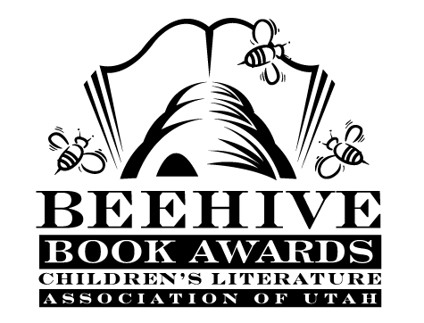
Children’s Fiction Books—Beehive Nominees 1999

- (Winner) Earthquake Terror by Peg Kehret
- The Ballad of Lucy Whipple by Karen Cushman
- The Butterfly Lion by Michael Morpurgo
- Ella Enchanted by Gail Carson Levine
- Flea Circus Summer by Cheryl Ware
- The Last Man's Reward by David Patneaude
- Lone Wolf by Kristine L. Franklin
- The Music of Dolphins by Karen Hesse
- The Stray by Dick King-Smith
- The Summer of the Bonepile Monster by Aileen Kilgore Henderson, illustrated by Kim David Cooper
- Thunder Cave by Roland Smith
- When the Circus Came to Town by Polly Horvath

Picture Books—Beehive Nominees 1999

- (Winner) Watch Out! Big Bro's Coming! by Jez Alborough
- Down the Road by Alice Schertle; illustrated by E.B. Lewis
- Edward and the Pirates by David McPhail
- Gotcha! by Gail Jorgensen; illustrated by Kerry Argent
- Mailing May by Michael O. Tunnell; illustrated by Ted Rand
- One Grain of Rice: A Mathematical Folktale by Demi
- Pigs in the Mud in the Middle of the Rud by Lynn Plourde; illustrated by John Schoenherr
- The Seven Silly Eaters by Mary Ann Hoberman; illustrated Marla Frazee
- Verdi by Janell Cannon
- Water Dance by Thomas Locker

Informational Books—Beehive Nominees 1999

- (Winner) Passage to Freedom: The Sugihara Story by Ken Mochizuki; illustrated by Dom Lee
- Anastasia's Album by Hugh Brewster
- Dinosaur Ghosts: The Mystery of Coelophysis by J. Lynett Gillette; pictures by Douglas Henderson
- The Honey Makers by Gail Gibbons
- Life and Times of the Peanut by Charles Micucci
- Lives of the Athletes: Thrills, Spills (And What the Neighbors Thought)
by Kathleen Krull; illustrated by Kathryn Hewitt
- The Most Beautiful Roof in the World: Exploring the Rainforest Canopy
by Kathryn Lasky
- Out of Darkness: The Story of Louis Braille by Russell Freedman; illustrated by Kate Kiesler
- The Secrets of Animal Flight by Nic Bishop
- Sidewalk Games Around the World by Arlene Erlbach

Young Adult Fiction Books—Beehive Nominees 1999

- (Winner) SOS Titanic by Eve Bunting
- After the War by Carol Matas
- Crash by Jerry Spinelli
- Don't You Dare Read This, Mrs. Dunphrey by Margaret Peterson Haddix
- Far North by Will Hobbs
- Letters from the Mountain by Sherry Garland
- Sabriel (Abhorsen Trilogy, book 1) by Garth Nix
- The Snake-Stone by Berlie Doherty
- Under the Mermaid Angel by Martha Moore
- The Unlikely Romance of Kate Bjorkman by Louise Plummer
- With Every Drop of Blood: A Novel of the Civil War by James Lincoln Collier and Christopher Collier.

