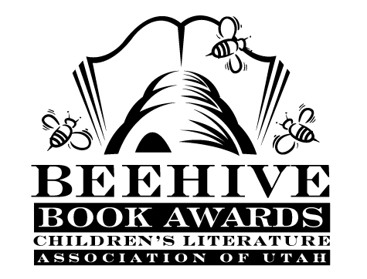
Children’s Fiction Books—Beehive Nominees 1998

- (Winner) Someone Was Watching by David Patneaude
- The 13th Floor: a Ghost Story by Sid Fleischman, illustrated Peter Sis
- Defenders of the Universe by D.V. Kelleher
- Dragonslayers by Bruce Coville
- Kokopelli's Flute by Will Hobbs
- Later, Gator by Laurence Yep
- Mr. Lincoln's Drummer by G. Clifton Wisler
- My Name is Brain Brian by Jeanne Betancourt
- The Private Notebook of Katie Roberts, Age 11 by Amy Hest, illustrated by Sonja Lamut
- Running Out of Time by Margaret Peterson Haddix
- Tornado by Betsy Cromer Byars and Doron Ben-Ami
- You're Dead, David Borelli by Susan M. Brown

Picture Books—Beehive Nominees 1998

- (Winner) Anansi and the Talking Melon by Eric A. Kimmel; illustrated by Janet Stevens
- Fanny's Dream by Caralyn Buehner; illustrated by Mark Buehner
- Homeplace by Anne Shelby; illustrated by Wendy Anderson Halperin
- How Many, How Many, How Many by Rick Walton; illustrated by Cynthia Jabar
- Just a Little Bit by Ann Tompert; illustrated by Lynn Munsinger
- Lilly's Purple Plastic Purse by Kevin Henkes
- Miss Spider's Tea Party by David Kirk
- More Than Anything Else by Marie Bradby; illustrated by Chris K. Soentpiet
- When the Teddy Bears Came by Martin Waddell; illustrated by Penny Dale
Whitefish Will Rides Again by Arthur Yorinks; illustrated by Mort Drucker

Informational Books—Beehive Nominees 1998

- (Winner) It's a Spoon, Not a Shovel by Caralyn Buehner; illustrated by Mark Buehner
- Children Just Like Me: In Association with UNICEF by Barnabas & Anabel Kindersley
- Children of China: An Artist's Journey by Song Nan Zhang
- The Children of Topaz: The Story of a Japanese-American Internment Camp: Based on a Classroom Diary by Michael O. Tunnell and George W. Chilcoat
- Color by Ruth Heller
- Daily Life in a Covered Wagon by Paul A. Erickson
- Immigrants (Library of Congress) by Martin W. Sandler
- The Bone Detectives: How Forensic Anthropologists Solve Crimes and Uncover Mysteries of the Dead by Donna M. Jackson; photography by Charlie Fellenbaum
- Native Artists of North America (Rainbow Warrior Artists) by Reavis Moore
- This Is The Place! A Crossroads of Utah's Past by Pat and Will Bagley

Young Adult Fiction Books—Beehive Nominees 1998

- (Winner) The Merlin Effect by T.A. Barron
- Beyond the Burning Time by Kathryn Lasky
- How I Changed My Life by Todd Strasser
- Indio by Sherry Garland
- Missing Pieces by Norma Fox Mazer
- The Only Alien on the Planet by Kristen D. Randle
- Phoenix Rising by Karen Hesse
- Rio Grande Stories by Carolyn Meyer
- Sarah On Her Own by Karen Mueller Coombs
- Thwonk by Joan Bauer
- Under the Blood-Red Sun by Graham Salisbury
- Winners and Losers by Stephen Hoffius

