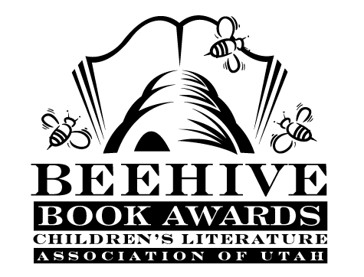
Children’s Fiction Books—Beehive Nominees 1997

- (Winner) Watchdog and the Coyotes by Bill Wallace, illustrated by David Slonim
- Backyard Dragon by Betsy Sterman and Samuel Sterman, photographed by David T. Wenzel
- Cat Running by Zilpha Keatley Snyder
- There's an Owl in the Shower by Jean Craighead George, illustrated by Christine Herman Merrill
- The Fear Place by Phyllis Reynolds Naylor
- Fig Pudding by Ralph Fletcher
- Jackson Jones and the Puddle of Thorns (Jackson Jones, book 1) by Mary Quattlebaum
- Silent Storm by Sherry Garland
- Tarantula Shoes by Tom Birdseye
- Titanic Crossing by Barbara Williams
- The Twin in the Tavern by Barbara Brooks Wallace
- The Well: David’s Story by Mildred D. Taylor

Picture Books—Beehive Nominees 1997

- (Winner) A Job for Wittilda by Caralyn Buehner; illustrated by Mark Buehner
- A Regular Flood of Mishap by Tom Birdseye; illustrated by Megan Lloyd
- Boundless Grace by Mary Hoffman; illustrated by Caroline Binch
- Coyote Steals the Blanket by Janet Stevens
- Martha Speaks by Susan Meddaugh
- My Rotten Redheaded Older Brother by Patricia Polacco
- Once There Was a Bull...(frog) by Rick Walton; illustrated by Greg Hally
- The Rattlebang Picnic by Margaret Mahy; illustrated by Steven Kellogg
- Under the Moon by Dyan Sheldon; illustrated by Gary Blythe
- Yettele's Feathers by Joan Rothenberg

Informational Books—Beehive Nominees 1997

- (Winner) Never Take a Pig to Lunch: and Other Poems About the Fun of Eating by Nadine Bernard Westcott
- A Pioneer Sampler: The Daily Life of a Pioneer Family in 1840 by Barbara Greenwood
- Adventure in Space: The Flight to Fix the Hubble by Elaine Scott
- Ancient Ones: The World of the Old-Growth Douglas Fir by Barbara Bash
- The Dragons are Singing Tonight by Jack Prelutsky; illustrated by Peter Sis
- Kids at Work: Lewis Hine and the Crusade Against Child Labor by Russell Freedman; photography by Lewis Hine
- The Story of Ruby Bridges by Robert Coles; illustrated by George Ford
- Tutankhamen's Gift by Robert Sabuda
- What Does the Crow Know? : The Mysteries of Animal Intelligence
by Margery Facklam; illustrated by Pamela Johnson
- The Young Author's Do-It-Yourself Book How to Write, Illustrate, and Produce Your Own Book by Donna Guthrie, Nancy Bentley and Katy Arnsteen

Young Adult Fiction Books—Beehive Nominees 1997

- (Winner) In My Father's House by Ann Rinaldi
- Catherine, Called Birdy by Karen Cushman
- Cattail Moon by Jean Thesman
- Drummers of Jericho by Carolyn Meyer
- Harper and Moon by Ramon Royal Ross
- Haveli by Suzanne Fisher Staples
- Liars by P.J. Peterson
- The Man Who Loved Clowns by June Rae Wood
- The Primrose Way by Jackie French Koller
- The Shark Callers by Eric Campbell

