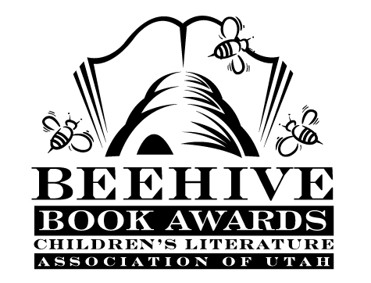
Children’s Fiction Books—Beehive Nominees 1996

- (Winner) Time for Andrew: a Ghost Story by Mary Downing Hahn
- Amber Brown Is Not a Crayon (Amber Brown, book 4) by Paula Danziger, illustrated by Tony Ross
- Bigger by Patricia Calvert
- The Cannibals of Sunset Drive by Dan K. Carlsruh
- Crossroads by Paul Pitts
- Just Call Me Stupid by Tom Birdseye
- Over the Joshua Slope by Lyman Hafen
- Scooter by Vera B. William
- The Shiniest Rock of All by Nancy Ruth Patterson
- Stardust by Alane Ferguson
- Terror at the Zoo by Peg Kehret
- Why Me? by Deborah Kent

Picture Books—Beehive Nominees 1996

- (Winner) Two of Everything: A Chinese Folk Tale by Lily Toy Hong
- Amber on the Mountain by Tony Johnston; illustrated by Robert A. Duncan
- Go Away, Big Green Monster by Ed Emberley
- Harvey Potter's Balloon Farm by Jerdine Nolen; illustrated by Mark Buehner
- The Itsy Bitsy Spider by Iza Trapani
- My Great-Aunt Arizona by Gloria Houston; illustrated by Susan Condie Lamb
- Owen by Kevin Henkes
- The Rough-Face Girl by Rafe Martin; illustrated by David Shannon
- Something From Nothing by Phoebe Gilman
- Stellaluna by Janell Cannon

Informational Books—Beehive Nominees 1996

- (Winner) Mummies and Their Mysteries by Charlotte Wilcox
- Zero Gravity by Gloria Skurzynski
- Incredible Edible Science by Tina L. Seelig; Lynn Brunelle
- The Librarian Who Measured the Earth by Kathryn Lasky; illustrated by Kevin Hawkes
- Lives of the Writers: Comedies, Tragedies (and What the Neighbors Thought) by Kathleen Krull; illustrated by Kathryn Hewitt
- Riddle-Me-Rhymes by Myra Cohn Livingston; illustrated by Rebecca Perry
- Rosie, a Visiting Dog's Story by Stephanie Calmenson; photograhy by Justin Sutcliffe
- Safari Beneath the Sea: the Wonder World of the North Pacific Coast by Diane Swanson
- The Third Planet: Exploring the Earth from Space by Sally Ride and Tam O'Shaughnessy
- The Young Dancer by Darcy Bussell in association with the Royal Ballet School

Young Adult Fiction Books—Beehive Nominees 1996

- (Winner) Nothing to Fear by Jackie French Koller
- Angie by Pat Bezzant
- April and the Dragon Lady by Lensey Namioka
- The Big Wander by Will Hobbs
- Death Walk by Walt Morey
- The Fifth of March: A Story of the Boston Massacre by Ann Rinaldi
- Heart of a Champion by Carl Deuker
- Kiss the Dust by Elizabeth Laird
- Nightjohn by Gary Paulsen
- Song of the Buffalo Boy by Sherry Garland
- Song of the Gargoyle by Zilpha Keatley Snyder
- Squashed by Joan Bauer
- Walker of Time by Helen Hughes Vick

