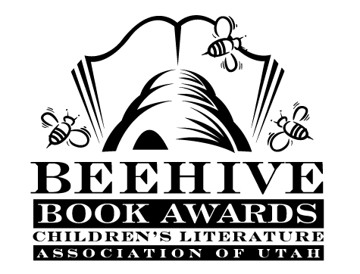
Children’s Fiction Books—Beehive Nominees 1995

- (Winner) Ghosts of Mercy Manor by Betty Ren Wright
- 213 Valentines by Barbara Cohen, illustrated by Wil Clay
- The Adventures of King Midas by Lynne Reid Banks
- Attaboy, Sam! (Anastasia Krupnick, book 10) by Lois Lowry
- The Boggart by Susan Cooper, illustrated by Omar Rayyan
- Boys Start the War (Boy/Girl Battle, book 1) by Phyllis Naylor
- Cages by Peg Kehret
- Chocolate-Covered Ants by Stephen Manes
- Death at Devil's Bridge by Cynthia C. DeFelice
- Hannah by Gloria Whelan, illustrated by Leslie Bowman
- Invisible Dog by Dick King-Smith
- Jacob's Bridge by Malka Drucker
- Little House on Rocky Ridge (Little House: the Rose Years, book 1)
by Roger Lea MacBride, illustrated by David Gilleace
- Maria: a Christmas Story by Theodore Taylor
- The Morning Glory War by Judy Glassman
- Orp Goes to the Hoop by Suzy Kline
- The Stuttgart Nanny Mafia by Susan Fletcher
- Uptime, Downtime by John Peel
- Windcatcher by Avi

Informational Books—Beehive Nominees 1995

- (Winner) Sadako by Eleanor Coerr; illustrated by Ed Young
- Across America on an Emigrant Train by Jim Murphy
- Creatures That Glow: A Glow in the Dark Book by Joanne Barkan
- Eating the Plates: A Pilgrim Book of Food and Manners by Lucille Recht Penner
- Eleanor Roosevelt: A Life of Discovery by Russell Freedman
- Greek Myths by Geraldine McCaughrean
- Lives of the Musicians: Good Times, Bad Times (and What the Neighbors Thought) by Kathleen Krull; illustrated by Kathryn Hewitt
- Look What I Did With a Leaf! by Morteza E. Sohi
- Many Thousand Gone: African Americans from Slavery to Freedom by Virginia Hamilton; illustrated by Leo Dillon and Diane Dillon
- Soap Science: A Science Book Bubbling with 36 Experiments by J.L. Bell; illustrated by William Kimber

Young Adult Fiction Books—Beehive Nominees 1995

- (Winner) Amazing Gracie by A. E. Cannon
- Across the Grain by Jean Ferris
- The Brave by Robert Lipsyte
- Dealing with Dragons (The Enchanted Forest Chronicles, book 1) by Patricia C. Wrede
- Flight #116 is Down! by Caroline B. Cooney
- Land of Hope (Ellis Island, book 1) by Joan Lowery Nixon
- Nothing But the Truth by Avi
- Steal Away by Jennifer Armstrong
- Trouble with Lemons by Daniel Hayes
- When the Road Ends by Jean Thesman
- White Lilacs by Carolyn Meyer

