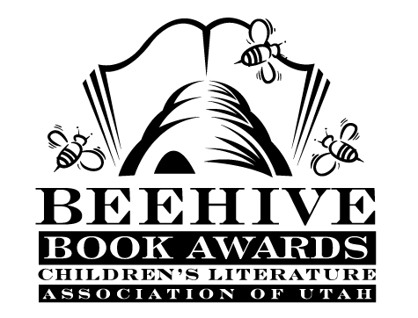
Children’s Fiction Books—Beehive Nominees 1994

- Winner) Jeremy Thatcher, Dragon Hatcher (Magic Shop Books, book 2)
by Bruce Coville, illustrated by Gary A. Lippincott
- Away is a Strange Place to Be by H.M. Hoover
- Coaching Ms. Parker by Carla Heymsfeld, illustrated by Jane O’Conor
- Finding Buck McHenry by Alfred Slote
- Flawed Glass by Ian Strachan
- Journey by Patricia MacLachlan
- The Knights of the Kitchen Table (Time Warp Trio, book 1) by Jon Scieska
- Letters from Rifka by Karen Hesse
- Little Brother by Allan Baille
- The Night the Bells Rang by Natalie Kinsey-Warnock, illustrated by Leslie W. Bowman
- Nightmare Mountain by Peg Kehret
- The Practical Joke War by Alane Ferguson
- The Shadowman's Way by Paul Pitts
- Shoebag by Mary James
- Stepping on the Cracks by Mary Downing Hahn
- Words of Stone by Kevin Henkes
- Yang the Youngest and His Terrible Ear by Lensey Namioka

Informational Books—Beehive Nominees 1994

- (Winner) Steven Biesty’s Incredible Cross Sections by Richard Platt; illustrated by Stephen Platt
- Come Back, Salmon: How a Group of Dedicated Kids Adopted Pigeon Creek and Brought it Back to Life by Molly Cone; photography by Sidnee Wheelwright
- Inner Chimes: Poems on Poetry by Bobbye S. Goldstein; illustrated Jane Breskin Zalben
- Into the Mummy’s Tomb: Real-life Discover of Tutankhamun's Treasures by Nicholas Reeves
- Light by David Burnie
- Living Dangerously: American Women Who Risked Their Lives for Adventure by Doreen Rappaport
- Mistakes that Worked by Charlotte Foltz Jones; illustrated by John O’Brien
- Prairie Visions: The Life and Times of Solomon Butcher by Pam Conrad
- A Separate Battle: Women and the Civil War by Ina Chang
- Where on Earth: a Geografunny Guide to the Globe by Paul Rosenthal; illustrated by Marc Rosenthal

Young Adult Fiction Books—Beehive Nominees 1994

- (Winner) The True Confessions of Charlotte Doyle by Avi
- Anything to Win by Gloria D. Miklowitz
- Dawn Rider by Jan Hudson
- How Could You Do It, Diane? by Stella Pevsner
- Lyddie by Katherine Paterson
- Monkey Island by Paula Fox
- Nightmare by Willo Davis Roberts
- Riders of the Silver Rim (Saga of the Sierras, book 2) by Brock and Bodie Thoene
- Shadow Brothers by A.E. Cannon
- The Shining Company by Rosemary Sutcliff
- Twenty Pageants Later by Caroline B. Cooney
- Year of Impossible Goodbyes by Sook Nyul Choi

