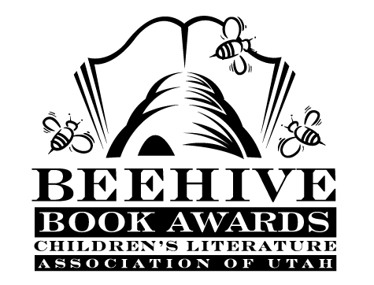
Children’s Fiction Books—Beehive Nominees 1993

- (Winner) The Dead Man in Indian Creek by Mary Downing Hahn
- Afternoon of the Elves by Janet Taylor Lisle
- Dynamite Dinah by Claudia Mills
- Fudge-a-Mania by Judy Blume
- Ghost Cadet by Elaine Marie Alphin
- Glass Slippers Give You Blisters by Mary Jane Auch
- Go Fish by Mary Stolz, illustrated by Pat Cummings
- Have a Happy…: a Novel About Kwanzaa by Mildred Pitts Walter, illustrated by Carole Bayard
- Higbee's Halloween by Robert Newton Peck
- Hugh Glass, Mountain Man by Robert McClung
- It's Not Easy Being George: Stories by Adam Joshua (and his dog) by Janice Lee Smith, illustrated Dick Gackenbach
- Sam and the Moon Queen by Alison Cragin Herzig and Jane Lawrence Mali
- My Grandmother's Stories: a Collection of Jewish Folk Tales by Adele Geras, illustrated by Anita Lobel
- Our Sixth-grade Sugar Babies by Eve Bunting
- Stepbrother Sabotage by Sally Wittman, illustrated by Emily Arnold McCully
- Strider by Beverly Cleary, illustrated Paul O. Zellinsky
- Weasel by Cynthia C. DeFelice
- The Year of the Panda by Miriam Schlein, illustrated Kam Mak
- Your Move, J. P. by Lois Lowry

Informational Books—Beehive Nominees 1993

- (Winner) Dolphin Adventure: a True Story by Wayne Grover; illustrated by Jim Fowler
- Amazing Butterflies and Moths by John Still
- American Tall Tales by Mary Pope Osborne; illustrated by Michael McCurdy
- Do People Grow on Family Trees? Genealogy for Kids and Other Beginners, The Official Ellis Island Handbook by Ira Wolfman and Alex Haley; illustrated by Michael Klein
- Escape From Slavery: Five Journeys to Freedom by Doreen Rappaport; illustrated by Charles Lilly
- For Laughing Out Loud: Poems to Tickle Your Funnybone by Jack Prelutsky; illustrated by Marjorie Priceman
- Hotshots: Baseball Greats of the Game When They Were Kids by Susan Sloate
- The Weather Sky by Bruce McMillan

Young Adult Fiction Books—Beehive Nominees 1993

- (Winner) Sniper by Theodore Taylor
- An Acceptable Time (A Wrinkle in Time, book 5) by Madeleine L'Engle
- Canyons by Gary Paulsen
- Children of the River by Linda Crew
- Downriver by Will Hobbs
- Face on the Milk Carton by Caroline B. Cooney
- Family Pose (Hardback: Family Picture) by Dean Hughes
- On Fortune's Wheel by Cynthia Voigt
- Show Me the Evidence by Alane Ferguson
- Strange Attractors by William Sleator
- Voices After Midnight by Richard Peck
- White Jenna (Great Alta Saga, book 2) by Jane Yolen

