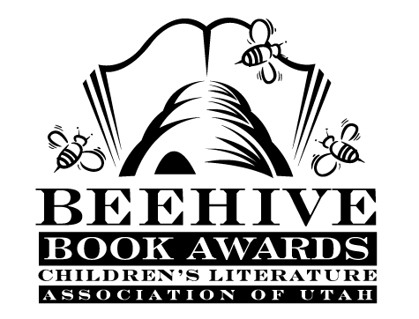
Children’s Fiction Books—Beehive Nominees 1992

- (Winner) There’s a Boy in the Girls' Bathroom by Louis Sachar
- Baseball in April and Other Stories by Gary Soto
- Bobby Baseball by Robert K. Smith, illustrated by Alan Tiegreen
- The Boy who Owned the School by Gary Paulsen
- The Burning Questions of Bingo Brown by Betsy Cromer Byars
- The Canada Geese Quilt by Natalie Kinsey-Warnock, illustrated Leslie W. Bowman
- Cricket and the Cracker Box Kid by Alane Ferguson
- Dangerous Ground by Gloria Skurzynski
- Eddie's Blue-winged Dragon by C.S. Adler
- The Fastest Friend in the West by Vicki Grove
- The Gold Cadillac by Mildred Taylor, illustrated by Max Ginsberg
- The High Rise Glorious Skittle Skat Roarious Sky Pie Angel Food Cake by Nancy Willard, illustrated by Richard Jesse Watson
- Martin's Mice by Dick King-Smith, illustrated by Jez Alborough
- Megan's Island by Willo Davis Roberts
- The Monster Garden by Vivien Alcock
- Muggy Maggie by Beverly Cleary
- My Name is not Angelica by Scott O'Dell
- Stargone John by Ellen Kindt McKenzie
- Vision Quest by Pamela F. Service
- Who Invited the Undertaker? by Ivy Ruckman

Informational Books—Beehive Nominees 1992

- (Winner) Ant Colony by Heiderose Fischer-Nagel
- Balloon Science by Etta Kaner
- In Your Own Words: A Beginner's Guide to Writing by Sylvia Cassedy
- Radical Robots: Can You Be Replaced? by George Harrar
- Rescue: The Story of How Gentiles Saved Jews in the Holocaust by Milton Meltzer
- The Restless Earth: The Secret of Earthquakes, Volcanoes, and Continental Drift by Francois Michel; illustrated by Yves Larvor

Young Adult Fiction Books—Beehive Nominees 1992

- (Winner) Don't Look Behind You by Lois Duncan
- A Killing Freeze by Lynn Hall
- A Sudden Silence by Eve Bunting
- December Stillness by Mary Downing Hahn
- The Fantastic Freshman by Bill Brittain
- The Island of Dangerous Dreams by Joan Lowery Nixon
- Mossflower (Redwall, book 2) by Brian Jacques and Gary Chalk
- No Way Home by Marilyn Levy
- Pocket Change by Kathryn Jensen
- Tell Us Your Secret by Barbara Cohen
- Wise Child by Monica Furlong

