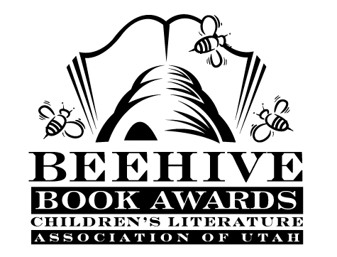
Children’s Fiction Books—Beehive Nominees 1990

- (Winner) This Island Isn't Big Enough for the Four of Us! by Gery Greer and Robert Ruddick
- Beethoven's Cat by Elizabet McHugh
- Black Star, Bright Dawn by Scott O'Dell
- Brothers of the Heart: a Story of the Old Northwest, 1837-1838 by Joan W. Blos
- The Case of the Watching Boy by Robert Newman
- Charley Skedaddle by Patricia Beatty
- Cry Uncle! by Mary Jane Auch
- Cuckoo Clock by Mary Stolz
- The Facts and Fictions of Minna Pratt by Patricia MacLachlan
- Gom on Windy Mountain (Tales of Gom in the Legends of Ulm, book 1)
by Grace Chetwin
- I'll Meet You at the Cucumbers by Lilian Moore, illustrated by Sharon Wooding
- The Illyrian Adventure (Vesper Holly, book 1) by Lloyd Alexander
- The Luck of Z.A.P. and Zoe by Athena V. Lord, illustrated by Jean Jenkins
- Magic Hat of Mortimer Wintergreen by Myron Levoy
- Mail-Order Kid by Joyce McDonald
- The Mermaid Summer by Mollie Hunter
- Redwall (Redwall, book 1--book 9 in chronological order)) by Brian Jacques
- Stinker from Space by Pamela F. Service
- Teacher's Pet by Joanna Hurwitz, illustrated by Shelia Hamanaka
- Woof! by Allan Ahlberg

Informational Books—Beehive Nominees 1990

- (Winner) How To Make Pop-Ups by Joan Irvine
- The Big Beast Book: Dinosaurs and How They Got that Way by Jerry Booth; illustrated by Martha Weston
- Linnea in Monet's Garden by Christina Bjork; illustrated by Lena Anderson; translated by Joan Sandin
- Round Buildings, Square Buildings & Buildings that Wiggle like a Fish by Philip M. Isaacson
- The Sun, the Wind and the Rain by Lisa Westberg Peters; illustrated by Ted Rand
- Super Flyers by Neil Francis
- The Wild Inside: Sierra Club's Guide to the Great Indoors by Linda Allison

