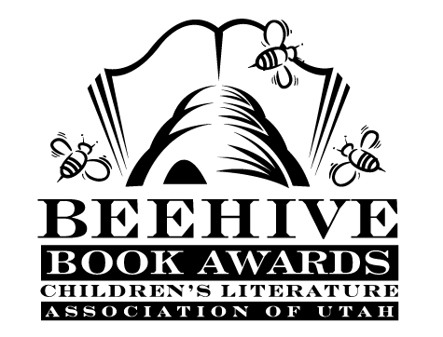
Children’s Fiction Books—Beehive Nominees 1989

- (Winner) Trapped in Death Cave by Bill Wallace
- Theo Zephyr by Dean Hughes
- Addie Across the Prairie by Laurie Lawlor
- Anastasia's Chosen Career (Anastasia Krupnik, book 7) by Lois Lowry
- Behave Yourself, Bethany Brant by Patricia Beatty
- Bodies in the Besseldorf Hotel (Besseldorf Hotel, book 2) by Phyllis R. Naylor
- Class Clown by Joanna Hurwitz, illustrated by Sheila Hamanaka
- Devil's Other Storybook by Natalie Babbitt
- Don't Call Me Toad by Mary Francis Shura
- Dr. Dredd's Wagon of Wonders by Bill Brittain, illustrated by Andrew Glass
- Ghost Drum by Susan Price
- Harry's Mad by Dick King-Smith
- House in the Snow by M.J. Engh
- The Miracle Tree by Christobel Mattingley, illustrated by Marianne Yamaguchi
- Mostly Michael by Robert Kimmel Smith
- Oliver Dibbs and the Dinosaur Cause by Barbara A. Steiner, illustrated by Eileen Christelow
- Pearl's Pirates by Frank Asch
- The Tar Pit by Tor Seidler
- This is your Captain Speaking by Ivy Ruckman
- Water Sky by Jean Craighead George

Informational Books—Beehive Nominees 1989

- (Winner) Your Amazing Senses by Ron Van Der Meer and Atie Van Der Meer; illustrated by Keiko Motoyama
- African Journey by John Chiasson
- American Revolutionaries: A History in Their Own Words 1750-1800 by Milton Meltzer
- Do Animals Dream? by Joyce Pope
- Go In and Out the Window: An Illustrated Songbook for Young People, music arranged and edited by Dan Fox; commentary by Claude Marks.

