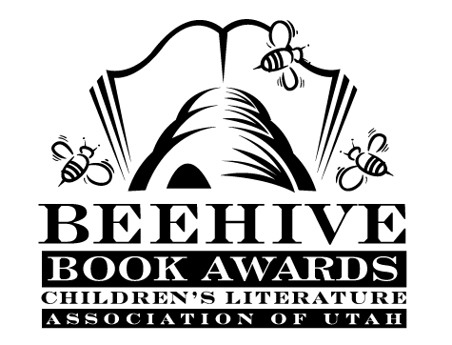
Children’s Fiction Books—Beehive Nominees 1988

- (Winner) Wait Till Helen Comes: a Ghost Story by Mary Downing Hahn
- Adventures of Johnny May by Robbie Branscum, illustrated by Deborah Howland
- After the Dancing Days by Margaret Rostowski
- Babe: the Gallant Pig by Dick King-Smith, illustrated by Maggie Kneen
- Building Blocks by Cynthia Voigt
- The Eternal Spring of Mr. Ito by Sheila Garrigue
- General Butterfinger by John Reynolds Gardiner, illustrated by Catherine Bowman Smith
- A Hidden Magic by Vivian Vande Velde, illustrated by Trina Schart Hyman
- The Magic Book by Willo Davis Roberts
- Me, My Goat, and My Sister's Wedding by Stella Pevsner
- More Stories Julian Tells by Ann Cameron, illustrated by Ann Strugnell
- The Not-Just-Anybody Family by Betsy Cromer Byars
- Prairie Songs by Pam Conrad
- Racso and the Rats of NIMH by Jane Leslie Conly, illustrated by Leonard Lubin
- Return of the Indian (The Indian in the Cupboard, book 2) by Lynne Reid Banks
- Streams to the River, River to the Sea by Scott O'Dell
- Switcharound by Lois Lowry
- Today's Special: Z.A.P. and Zoe by Athena V. Lord
- What Eric Knew by James Howe
Informational Books—Beehive Nominees 1988

- (Winner) How Much Is A Million? by David Schwartz; illustrated by Steven Kellogg
- Dinosaurs are Different by Aliki
- Goose Family Book by Sybille Kalas
- The Great Wall of China by Leonard Everett Fisher
- To Space and Back by Sally Ride and Susan Okie

