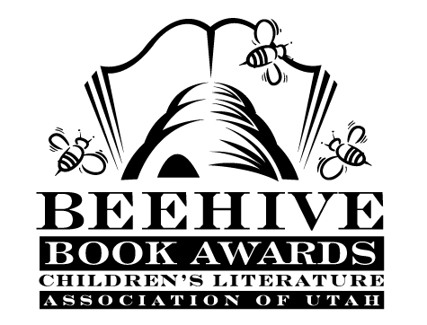
Children’s Fiction Books—Beehive Nominees 1987

- (Winner) Skinnybones by Barbara Park
- The Adventures of Ali Baba Bernstein by Johanna Hurwitz
- And Don't Bring Jeremy by Marilyn Levinson
- Blair's Nightmare by Zelpha Keatley Snyder
- A Blue-Eyed Daisy by Cynthia Rylant
- The Castle in the Attic by Elizabeth Winthrop
- Caught in the Moving Mountains by Gloria Skurzynski, illustrated by Ellen Thompson
- Come Sing, Jimmy Jo by Katherine Paterson
- The Dark Secret of Weatherend (Anthony Monday, book 2) by John Bellairs
- Ghost Cat by Beverly Butler
- Jackaroo (The Kingdom, book 1) by Cynthia Voigt
- Nay Nuki: Shoshoni Girl Who Ran by Kenneth Thomasma, illustrated by Eunice Hundley
- Nutty and the Case of the Ski-Slope Spy by Dean Hughes
- Quentin Corn by Mary Stolz, illustrated by Pamela Johnson
- The Root Cellar by Janet Lunn, illustrated by N.R. Jackson
- Search for Grissi by Mary Francis Shura
- Soup on Ice (Soup, book 8) by Robert Newton Peck, illustrated by Charles Robinson
- Stay Away from Simon! by Carol Carrick, illustrated by Donald Carrick
- The War with Grandpa by Robert Kimmel Smith
- A Chance Wild Apple by Marian Potter

