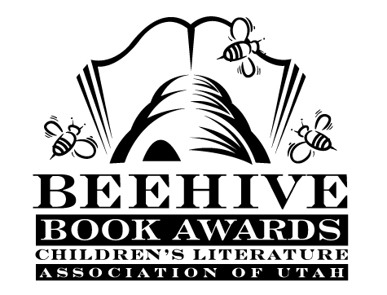
Children’s Fiction Books—Beehive Nominees 1986

- (Winner) Me and the Weirdos by Jane Sutton
- Acorn Quest by Jane Yolen, illustrated by Susanna Natti
- Eight Mules from Monterey by Patricia Beatty
- The Flunking of Joshua T. Bates (Joshua T. Bates, book 1) by Susan Shreve, illustrated by Diane de Groat
- The Ghosts of Austwick Manor by Reby Edmond MacDonald
- The Girl with the Silver Eyes by Willo Davis Roberts
- The Horse in the Attic by Eleanor Clymer
- I Be Somebody by Hadley Irwin
- In the Year of the Boar and Jackie Robinson by Bette Bao Lord, illustrated by Marc Simont
- Mitzi and Frederick the Great by Barbara Williams, illustrated by Emily Arnold McCully
- Night of the Twisters by Ivy Ruckman
- Out of the Bug Jar by Kathleen Thomas
- Rich Mitch by Marjorie Weinman Sharmat
- Scary Stories to Tell in the Dark by Alvin Schwartz, illustrated by Brett Helquist
- Switching Tracks by Dean Hughes
- The Talking Earth by Jean Craighead George
- Time's Up! by Florence Parry Heide
- Where's Buddy by Ron Roy
- The Wish Giver: Three Tales of Coven Tree by Bill Brittain, illustrated by Andrew Glass
- Zan Hagen's Marathon by R.R. Knudson

