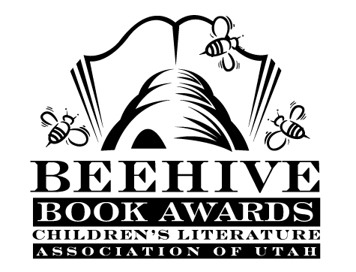
Children’s Fiction Books—Beehive Nominees 1985

- (Winner) Stone Fox by John Reynolds Gardiner, illustrated by Marcia Sewall
- Behind the Attic Wall by Sylvia Cassedy
- The Celery Stalks at Midnight (Bunnicula, book 3) by James Howe, illustrated by Leslie Morrill
- Chester Cricket's New Home (Chester Cricket, book 5) by George Selden
- The Curse of the Blue Figurine (John Bellairs Mysteries, book 2)
by John Bellairs
- Dancing Carl by Gary Paulsen
- Devil's Donkey by Bill Brittain
- The Gift by Joan Lowry Nixon, illustrated by Andrew Glass
- The Great Ringtail Garbage Caper by Timothy Foote
- Homesick: My Own Story by Jean Fritz
- The Journey of the Shadow Bairns by Margaret Jean Anderson
- Moffat Museum by Eleanor Estes
- The One Hundredth Thing About Caroline by Lois Lowry, illustrated by Diane de Groat
- Peppermints in the Parlor by Barbara Brooks Wallace
- The Pet-Sitting Peril by Willo Davis Roberts
- The Sign of the Beaver by Elizabeth George Speare
- Toad Food and Measle Soup by Christine McDonnell, illustrated by G. Brian Karas
- The Trouble with Tuck: The Inspiring Story of a Dog Who Triumphs Against All Odds by Theodore Taylor
- What a Whimp! by Carol Carrick

