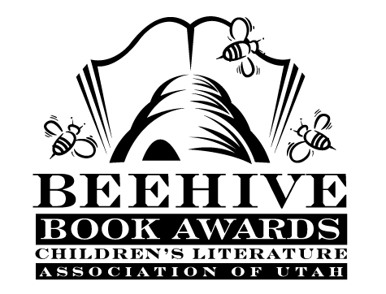

Children’s Fiction Books—Beehive Nominees 1984

- (Winner) Lost in the Devil's Desert by Gloria Skurzynski
- Anastasia Again by Lois Lowry
- Apple is my Sign by Mary Riskind
- Cat That Was Left Behind by Carol S. Adler
- Coydog: A Novel by Evelyn W. Mayerson
- Crystal Child by Barbara Wersba
- Hello, Wrong Number by Marilyn Sachs
- Honestly, Myron by Dean Hughes
- How It Feels When a Parent Dies by Jill Krementz
- I am the Cat by Lee Hopkins
- Journey to an 800 Number by E.L. Konigsburg
- New Neighbors for Nora by Joanna Hurwitz
- Night Journey by Kathryn Lasky
- Night Swimmers by Betsy Byars
- Pennies for the Piper by Susan McLean
- Ramona Quimby, Age 8 by Beverly Cleary
- Seventy-Nine Squares by Malcolm Bosse
- Summer Switch by Mary Rodgers
- Thousand Camps by Mary Waldorf
- Where Are You Angel von Hauptman Now That I Need You? by Barbara Williams

