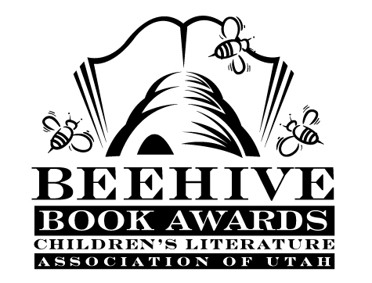
Children’s Fiction Books—Beehive Nominees 1983

- (Winner) Chocolate Touch by Patrick Catling
- Anastasia Krupnik by Lois Lowry
- Arthur the Kid by Alan Coren
- Bunnicula: A Rabbit Tale of Mystery by James and Deborah Howe
- Eddie, Incorporated by Phyllis Naylor
- First Travel Guide to the Moon by Rhoda Blumberg
- Fledgling by Jane Langton
- I Carve the Stone by Joan Fine
- Last was Lloyd by Doris B. Smith
- Legend of Scarface by Robert San Souci
- Long View into Space by Seymour Simon
- Nutty for President by Dean Hughes
- Save Queen of Sheba by Louise Moeri
- Son for a Day by Corinne Gerson
- Stories Julian Tells by Ann Cameron
- Throwing Shadows by E.L. Konigsburg
- Thor Heyerdahl: Viking Scientist by Wyatt Blassingame
- Westmark by Lloyd Alexander
- Words in Our Hands by Ada Litchfield

