**Children’s Literature Association of Utah**

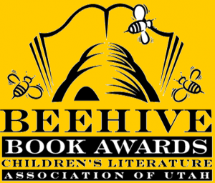**2013 Beehive Awards**

**Children’s Book**

***Lulu and the Brontosaurus***

by Judith Viorst,

illustrated by Lane Smith

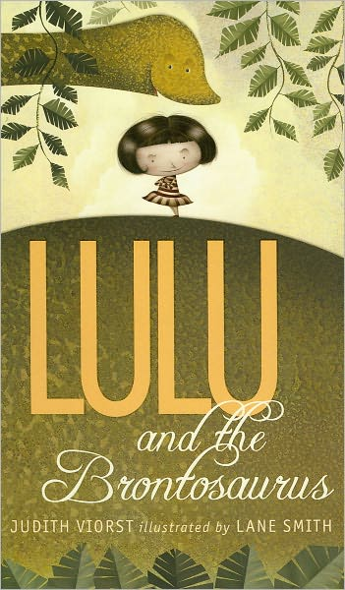

**Poetry Book**

***Won Ton: A Cat Tale Told in Haiku***

by Lee Wardlaw,

illustrated by Eugene Yolchin

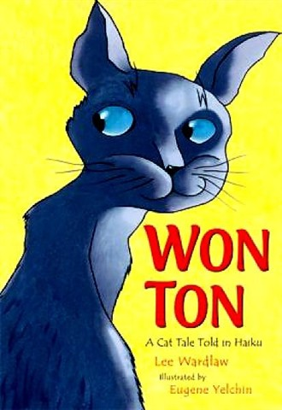

**Informational Book**

***Pop! The Invention***

***of Bubble Gum***

by Meghan McCarthy

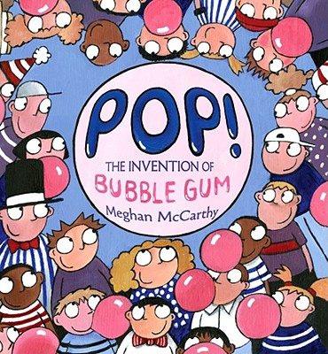

**Young Adult Book**

***The Running Dream***

By Wendelin

Van Draanen

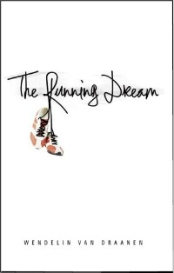

**Picture Book**

***Press Here***

by Herve Tullet

